‘A Postcard from Japan’

This task aims to give you the opportunity to find out more about the tourist attractions of Japan that interest YOU!
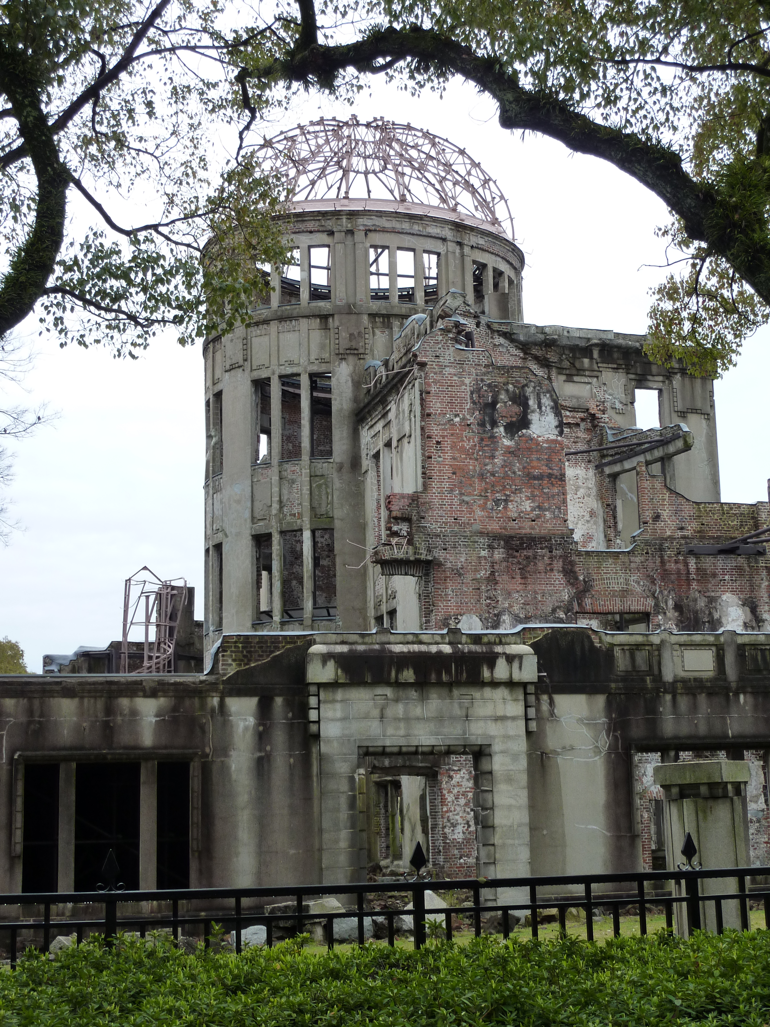
Description of Task
You are required to prepare a ‘postcard’ to send home from Japan (where you are currently touring) to a family member or friend.
- Your postcard needs to include details of 3 cities you plan to visit in Japan.
- In each of these 3 cities you must visit and describe 2 sites or activities you have visited or engaged in. Your descriptions should be written in such a way to convince the reader that you really are in Japan.
- Write your descriptions in your own words. No cut and paste, please!
- The back of your poster should be prepared as a collage. It should include a title, (for example, ‘Hello from Japan” - in Japanese of course!), a map (with cities visited identified and labelled) and images of each of the 6 sites you have visited. Your collage could be prepared using Picasa, Adobe Fireworks or Microsoft Auto Collage.

Bonus Marks will be given for:
- Key words written in kana, for example, the names of cities, the names of places visited, the names of activities engaged in. Also in hiragana, the title of your postcard and ‘to’ and ‘from’. Your name and the name of the person your letter is addressed to should be written in katakana.
- The inclusion of ‘cultural comments’. These comments do not just state the name of the place you have visited and what you have done there, but rather describe and explain what is different from Australia and also if possible, why.


Presentation
- Your postcard may be prepared using MS Word, MS Publisher’ or alternatively as a ‘glog’ via the online site www.glogster.com/

Assessment Criteria | High (5) | Medium (3) | Low (1)  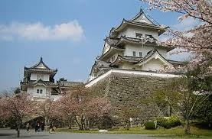
Content appropriately detailed, City 1 |  |  | 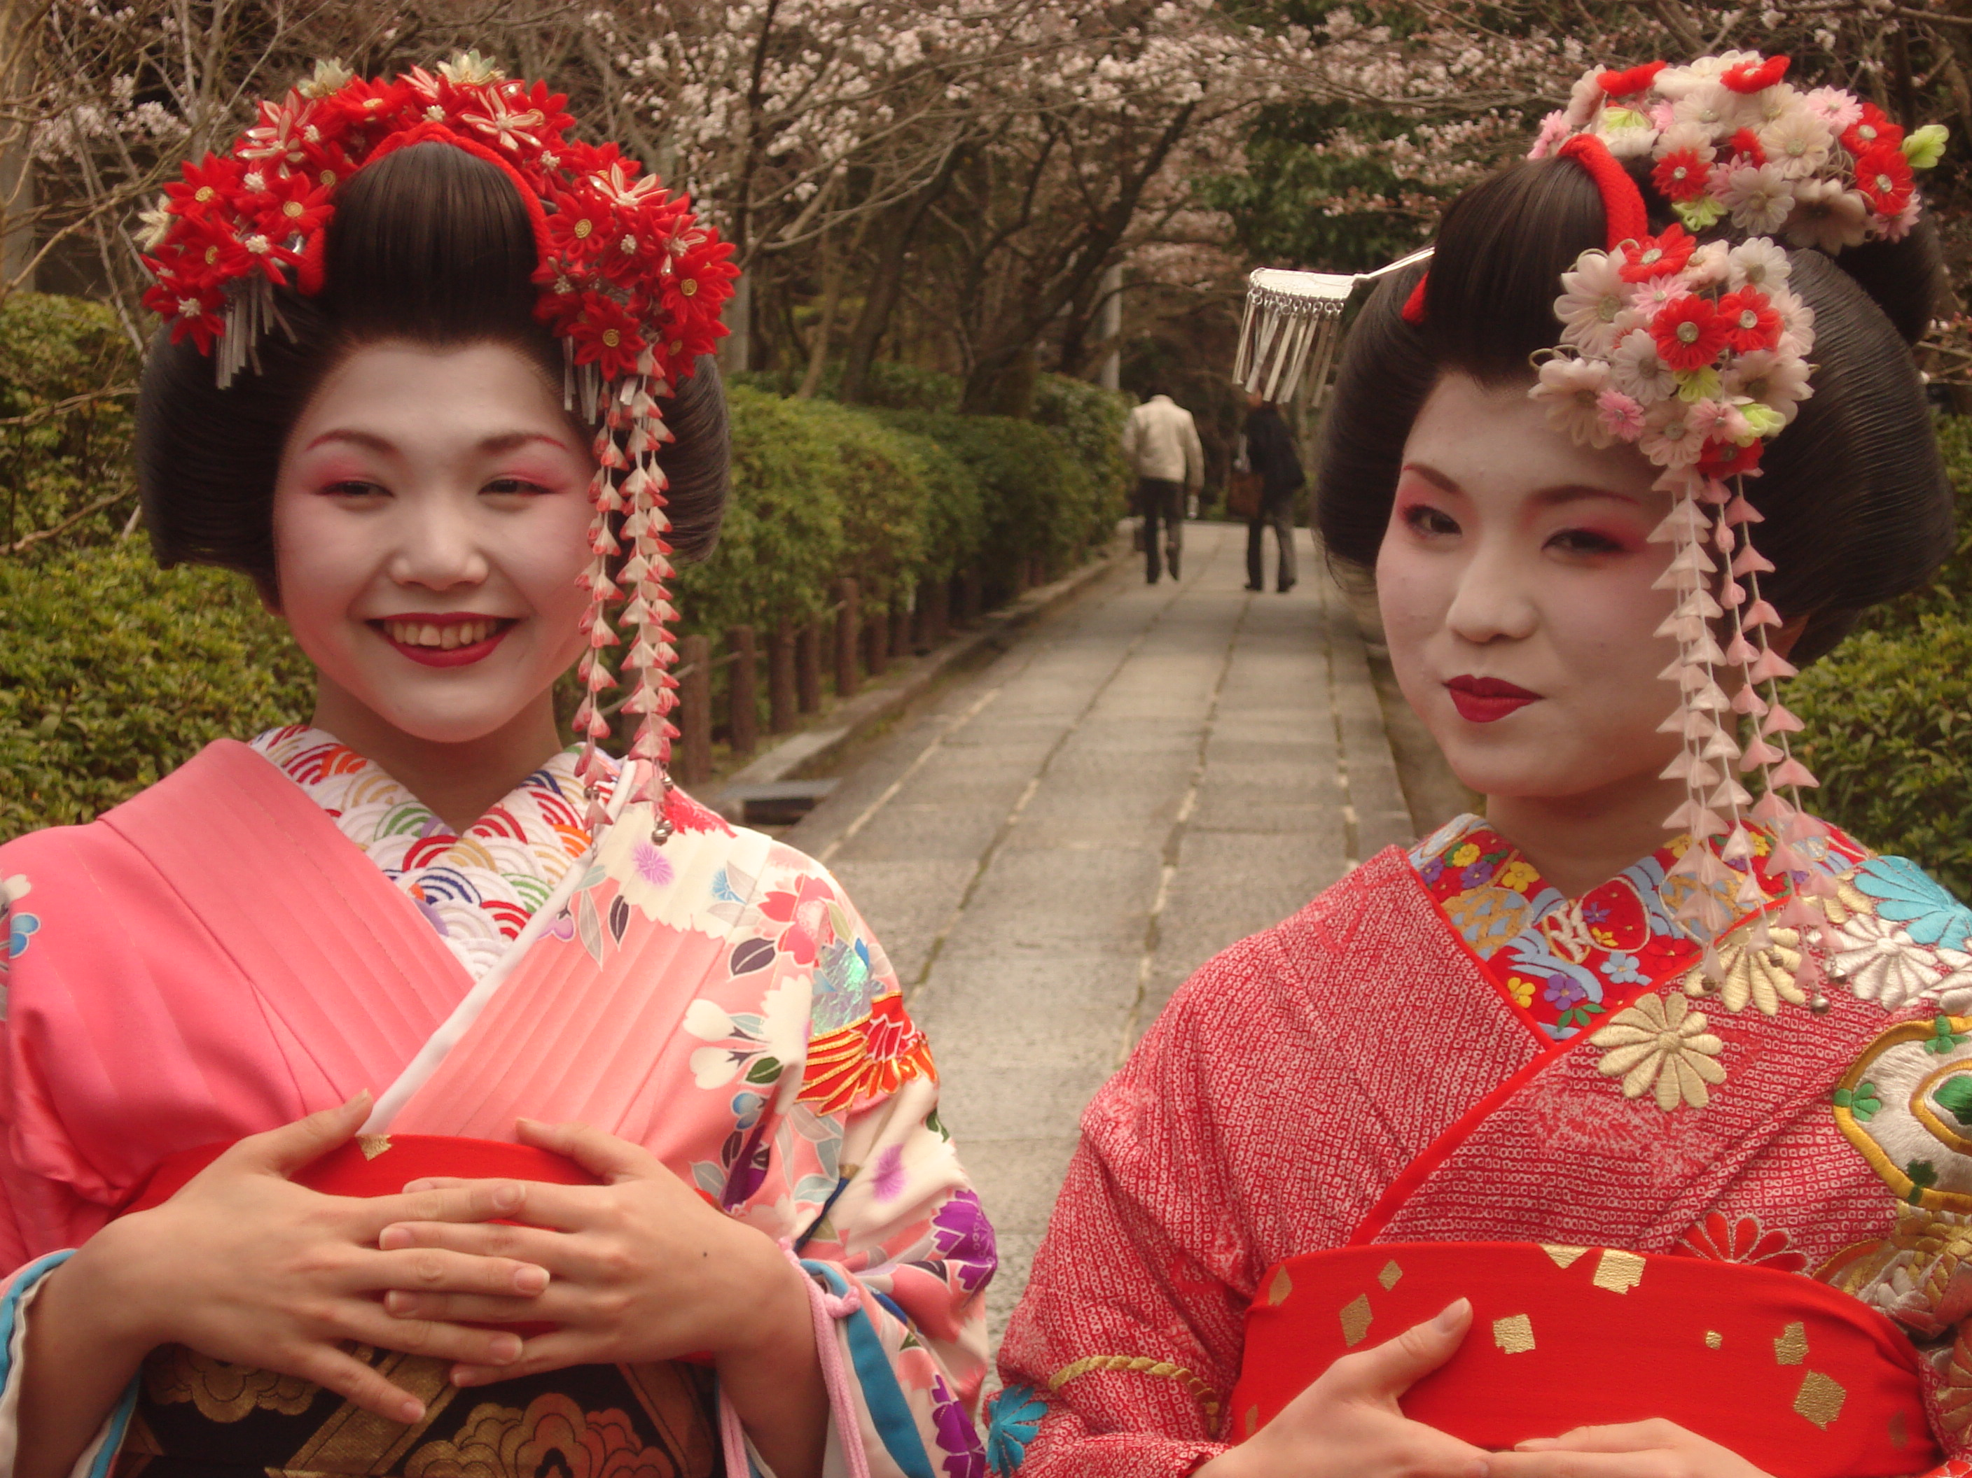
Content appropriately detailed, City 2
Content appropriately detailed, City 3
Editing (NOT cut and paste)
  Bonus Marks | High (5) | Medium (3) | Low (1)
  Cultural comments
  Inclusion of Kana
Proof-reading (no spelling errors, correct punctuation etc.)
Logical & attractive Presentation

Websites: http://www.japan-guide.com http://web-japan.org/kidsweb/index.html

