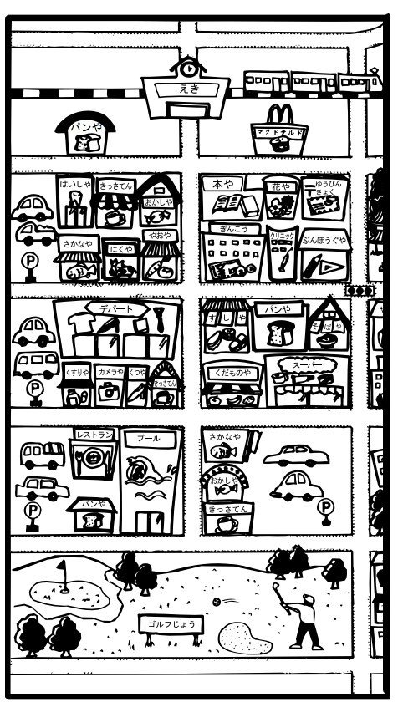

Yuubinkyoku

Kissaten

Puuru

Depāto

Ginkō

Eki

**ホテル**

You are a hotel receptionist. Here is a map of the local area. Help any hotel guests with any questions they may have about places in the local area.

Hai,、PLACE ga arimasu.

Iie, PLACE wa arimsen.

Place1 wa　Place2　no　Preposition　desu.

Kono biru desu.



**ホテル**

**?**

**?**

**?**

**?**

This is a map of the Japanese town you are staying in. You want to know where the following things are, ask your hotel receptionist:

* bank
* pool
* post office
* train station
* police box
* McDonalds
* coffee shop
* department store

***Mark the places on your map.***

Kono chikaku ni Place　wa arimasu ka?

Shitsurei desu ga, Place　wa doko desu ka?

Koko desu ka?

Kono biru desu ka?

Hai, wakarimashita.

**?**

**?**

**?**