Name: ________________________________ Date: ________________ Period: ______

Directions:
Read the following on greetings used in Japanese (with animations). Then answer the questions below.
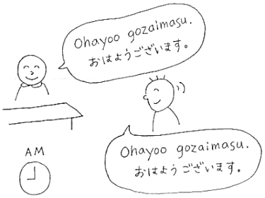
Ohayou gozaimasu. （おはようございます。） - Good morning.
Sounds like “Ohio gozai mas”. One can also say just "Ohayou （おはよう）". This is casual, and should not be used with someone of higher authority (like your teacher!).

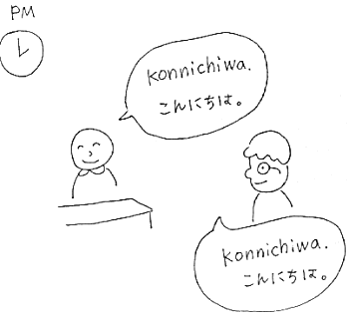

Konnichiwa. （こんにちは。） - Hello/Good afternoon.
Sounds like kon nee chee wa. There is no distinction between informal and formal. Konnichiwa is used for friends, parents, teachers, anybody!
Literally means “Today is…”.

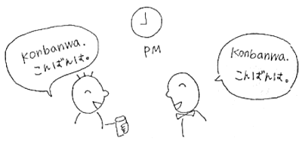
Konbanwa. （こんばんは。） - Good evening.
Sounds like kon bon wa. Like konnichiwa, there is no informal or formal distinction. This is usually said more towards nighttime.
Literally means, “Tonight is…”.
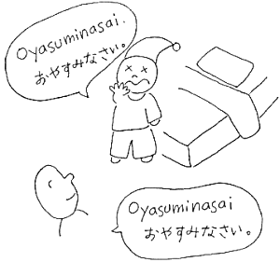

Oyasuminasai. （おやすみなさい。） - Good night.
Sounds like oya su mee na sai. Used only before going to bed. There is an informal way to say it (to friends, for instance) and that is oyasumi (おやすみ). Do not use oyasumi with adults, however.

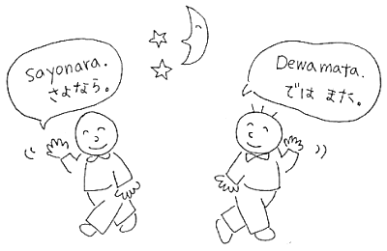
Sayounara. （さようなら。）- Good-bye.
Sounds like sa yoo na ra. Used mainly when leaving places other than your own home. Informally, you can also say "Dewa mata (ではまた)” or “Jaa mata (じゃあまた)” but these should be used with friends only.

Ogenki desu ka. (おげんきですか。) – How are you?
Sounds like o gen kee des ka. In Japanese “ka” is the question marker so there is no need to write “?” at the end of a sentence.
The response for this is “Genki desu.” (げんきです。) meaning “I’m fine.” If you are ill, you should say so, as in Japanese it is polite to warn others of a contagious illness.
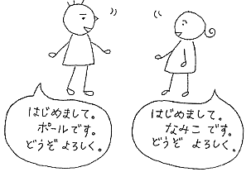
Hajimemashite. (はじめまして。) – Nice to meet you.
Sounds like ha ji may ma shte. There is no formal or informal differences. Used This should only be used the first time you meet someone. This might be followed by “Douzo Yoroshiku onegaishimasu” This translates roughly as “pleasure to meet you” but literally means “please be nice to me”.

Arigatou gozaimasu. (ありがとうございます。) – Thank you.
Sounds like ari gato go zai mas. This is the formal way to say thank you. To add “very much” just say “Doumo” (どうも) before arigatou. To make this informal, you can just say arigatou or doumo. Think “Domo Arigato Mr. Roboto”.

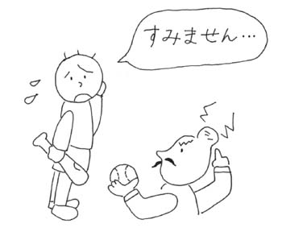

Sumimasen. (すみません。) – I’m sorry/ Excuse me.
Sounds like sue mee ma sen. This phrase is used both as “I’m sorry” and as “Excuse me”. The Japanese usually bow when they say this (and do not make eye contact as they bow). Another way to say “I’m sorry” is “gomennasai” (ごめんなさい). A very casual way (only used with friends) is “warui na” (わるいな) which is like saying “my bad”.

Name: ________________________________ Date: ________________ Period: ______
Practice-
What are these people saying? Write the appropriate Japanese greeting under each picture.

 
 
 
 

