Anime Research Assignment
Task 1: Research task
- What is the history of anime in Japan?
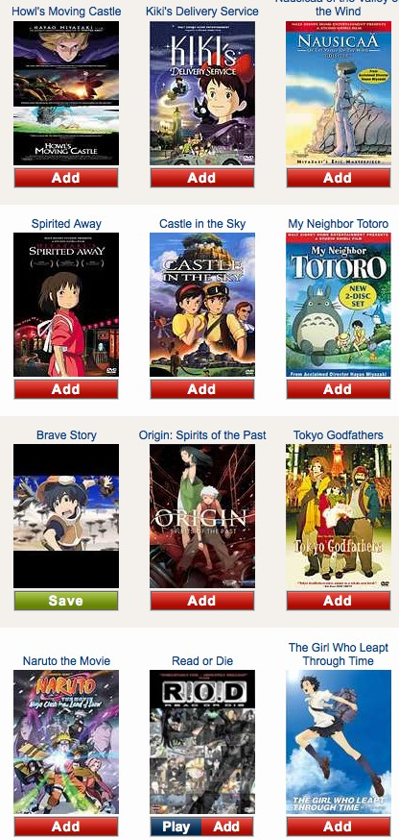
- Name some famous Japanese anime characters.
- What are some characteristics of Japanese anime?
- Name 2 famous Japanese anime directors and include some of their films.
- Research a famous Japanese anime.
  - What is the name of the film?
  - Who is the director?
  - Name the main characters.
  - What is the plot?
  - What did you think about the film?
- Why is anime so popular in Japan?

Task2: Presentation
Make a Presentation about Anime using the information you have found and any other interesting facts.
You will be marked on:
- The detail of information
- Your inclusion of a bibliography and pictures
- How well it is presented

Total marks: 20
Due: ________________

