*Name*

Draw a picture of the athlete.

*Age*

*Country*

Draw the flag and label

the colours.

*Flag*

[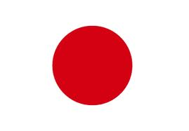](http://www.google.com.au/imgres?imgurl=http://www.japanorama.com/images/Hinomaru_364x254.gif&imgrefurl=http://www.japanorama.com/hinomaru.html&h=254&w=364&sz=2&tbnid=TQJ7MonDstgMKM:&tbnh=90&tbnw=129&zoom=1&docid=VGa152kM4KVpKM&sa=X&ei=VB16T-zmEOe3iQfLoOXhBA&ved=0CEsQ9QEwAg&dur=1298)

*Currently living in*

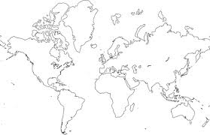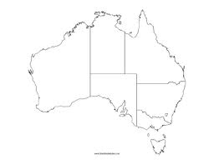

*Good at….*

*Likes….*

*Not so good at….*