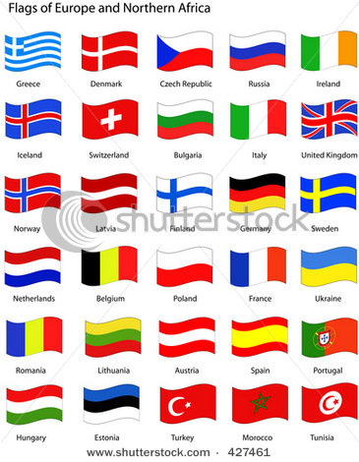
What country are you from?
Doko kara kimashita ka?
- Hajime mashite. XX (name) desu/to moushimasu.
- Pleased to meet you. My name is XX.

- Igirisu-jin desu
- I am English
or
- Igirisu desu
- I am from England

Aisurando desu  Airurando –jin desu  Amerikagasshuukoku-jin desu  Denmaaku desu  Ejiputo desu  Finrando-jin desu  Girisha desu  Hungarii-jin desu  Igirisu-jin desu  Indo-jin desu  Isuraeru desu  Itaria –jin desu  Kanada-jin desu  Oosutoraria desu  Oranda desu  Noruwee-jin desu  Nippon-jin desu  Kankoku desu  Roshia-jin desu  Suweeden-jin desu  Supein-jin desu  Chuugoku desu  Toruko desu  Doitsu-jin desu  Nyuu jiirando desu  Furansu-jin desu | I am from Iceland √  I am Irish √  I am ____________________________  I am ____________________________  I am ____________________________  I am ____________________________  I am ____________________________  I am ____________________________  I am ____________________________  I am ____________________________  I am ____________________________  I am ____________________________  I am ____________________________  I am ____________________________  I am ____________________________  I am ____________________________  I am ____________________________  I am ____________________________  I am ____________________________  I am ____________________________  I am ____________________________  I am ____________________________  I am ____________________________  I am ____________________________  I am ____________________________  I am ____________________________

French  Spanish  Korea  American  Russian  Indian  Egypt | Ireland  China  Australia  New Zealand  Japanese  Greece  Denmark | German  Italian  English  Iceland  Norwegian  Hungarian | Turkey  Swedish  Holland/Netherlands  Israel  Canadian  Finnish

