Name: ______________________
Grade: ______________________
Date: ______________________

ABC School

Japanese “My day” You-Tube Assignment

Theme: How I express myself
Due Date: …………………………………………………
Task: Make a You Tube Video using Photo Story 3
Length: 9 frames – 15 frames

Task description:
A group of Japanese students are coming to your school as tourists. They would like to know what a typical day in the life of an Australian student is like. You are going to make a short You Tube video (using Photo Story 3) in Japanese that explains a typical day in your life. You will:
- Write ‘My day’ plan. This will include sentences in Hiragana and Romaji describing a typical day in your life (use the dictionary to help you). (Minimum of 9 sentences.)
- Find appropriate pictures (on the Internet) or take digital photos that match your ‘My day’ plan. Save the pictures onto a USB stick.
- Import the pictures into Photo Story 3. Put them into an appropriate order. Remove any black borders. (Minimum of 9 frames)
- Type in Japanese (hiragana) a short description for each picture.
- Read your description in Japanese for each picture. (Use ‘My plan’ sentences to help you with pronunciation.)
- Save the finished video onto a USB.
- Submit the video and drafts/plans to the teacher.

Conditions:
- Bring a USB to each class.
- Don’t forget to save your project at the end of each class.
- This is an individual assignment so each student must hand in his or her own story.

Boku no ichi nichi (My day)
なまえ：

This is a short description of Yuuki’s day. Put the pictures into the correct order by writing a number under each picture. Watch the video http://www.youtube.com/watch?v=ps7TNSTLsaM to check your answers.

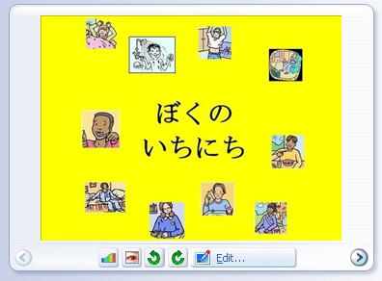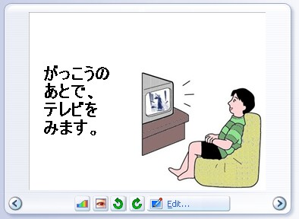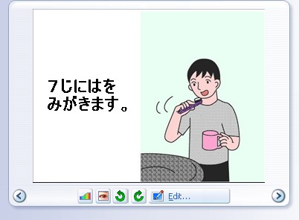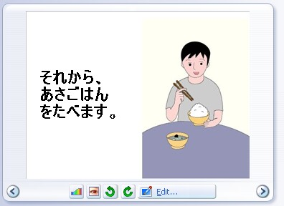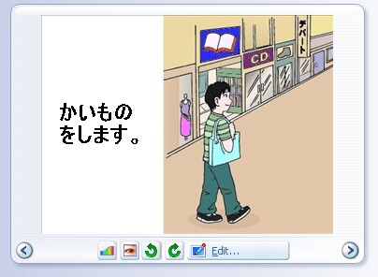
1 ________ ________ ________ ________
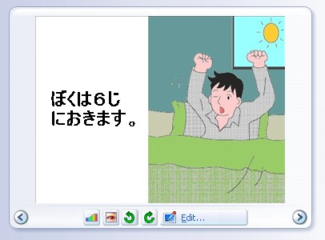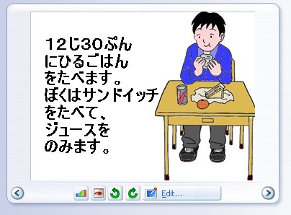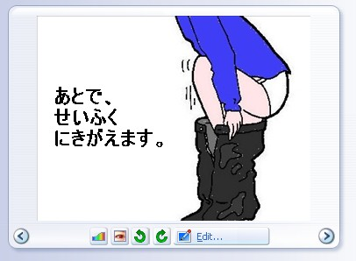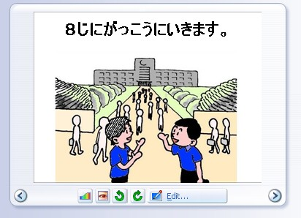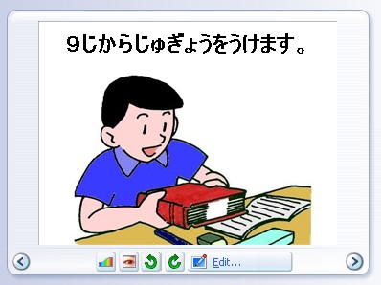
________ ________ ________ ________ ________
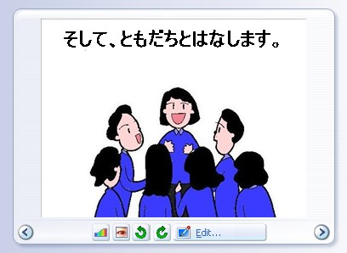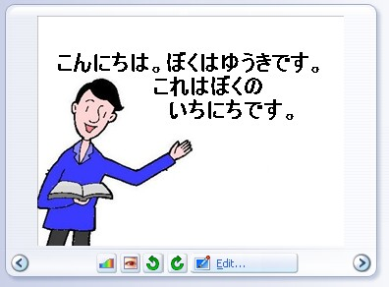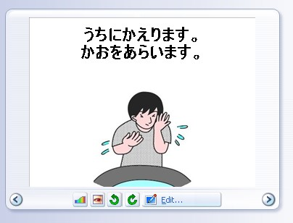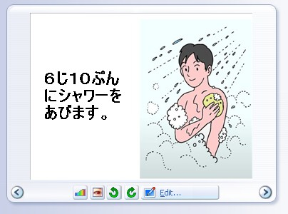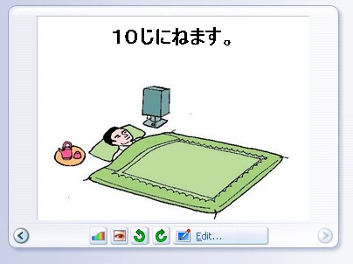
15
________ ________ ________ ________
Photostory3 planning sheet
なまえ：

