Culture Assignment- Design a GLOGS- online multimedia poster
Date Due:
Weighting:
Task Type: Glogs-Online multimedia poster
Outcomes:
4.MBC.2 | demonstrates knowledge of key features of the culture of Japanese-speaking communities.
ICT | collects and interprets electronic information
Task Outline: Research One famous Japanese cultural event or festival. your teacher will give you a specific month to work on. Create a Glogs -- Online multimedia poster with text, photos, videos, graphics, sound drawing, data attachment etc. about any event or cultural festival in Japan in your allocated month. Present in front of the class about the event and festival. (you may need to include the information about the significances of the festival and what the people do etc. ) You must put the name of festival, the month and the word for “festival” in Japanese. Do you still remember how to type Japanese? (かんじpreferred).
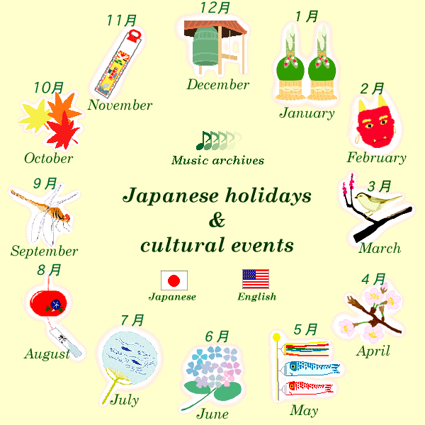
Task Preparation: you need to
- Sign up an account of Edmodo (www.edmodo.com). If you have already had one, log in. Our group code is “ ”. Join in this group. Your teacher will post the some essential documents there.
- Sign up an account as a student in http://edu.glogster.com in order for you to start to create your poster. Teacher’s code is:
- Obtaining information from a number of different and varied sources; analysing, evaluating and synthesizing information; writing a plan; writing using language which is non-plagiarised.
- Prepare some palm cards for your oral presentation.

Time frame and Submission Requirements:
Period_____Date______:sign up Edmodo account and Glogster account. Work on your poster.
(you may need to spend some time at home on your work as you will share one computer in the library)
Period_____Date______:work on and finalize your poster. You need Edmodo to leave you URL address so that the teacher can access your poster via the URL address.
Due date:
Class presentation: Period_____Date______

My month is:______________________________________________

Marking
The task is worth 20 marks.
The task will be marked as follows:
- 1-10 marks quality of information (accuracy, detail, relevance, interest) and use of non- plagiarised language.
- 1-5 marks Design of Glogs
- 1-5 marks Oral presentation about the festival based on Glogs (no more than 3 minutes)

