Task:
Create a poster illustrating the meanings of various Japanese greetings.
- Include a picture clearly showing the meaning of the greeting
- Write the romaji and hiragana for each greeting
- Translate the greeting into English

Example poster:

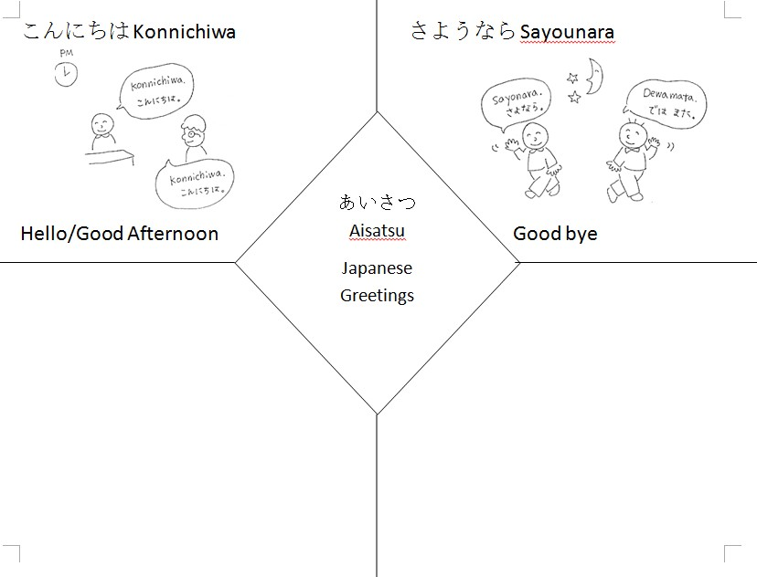

Marking criteria:

Score | 5 | 10 | 20 | Total
Hiragana | Drawn, but not accurate. | Drawn mostly accurately; few errors. | Hiragana is drawn accurately and perfectly.
Picture | Has pictures, but unclear as to what they represent. | Pictures mostly represent word(s). | Pictures are accurate and well-drawn.
Romaji | Has romaji, but doesn’t match up with the hiragana. | Has romaji, but not for everything or few do not match up. | Romaji matches and is shown in the examples.
Translation | Translations do not match up more than 50% of the time. | Translations match up 90-50% of the time. | Translations match more than 90% of the time.
Creativity/Effort | Little to no effort shown. | Good time spent, but could be better. | Beautifully done; time well spent.
 |  |  | Total:

