Guess Who?

Jessica Smith | Sally Field  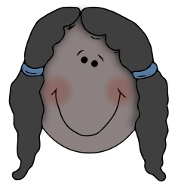 | Midori Tanaka 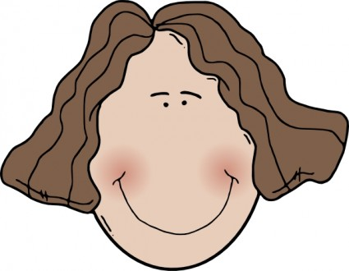 | Yumi Hashimoto
Amerika  Nūyōku  Eigo no Sensei  kanai | Ōsutoraria  Burisuben  Eigo no Sensei gārufurendo | Igirisu  Rondon  Nihongo no Sensei gārufurendo | Amerika  Nūyōku  Nihongo no Sensei  kanai
Mike Green | Todd Yamada 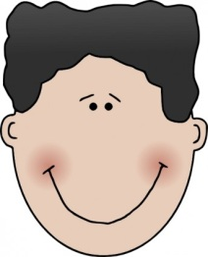 | Geoff Brown | Chris Thompson
Amerika  Nūyōku  enjinia  shujin | Igirisu  Rondon  enjinia  kareshi | Ōsutoraria  Burisuben  kaishain  shujin | Ōsutoraria  Burisuben  kaishain  kareshi
Haruo Ikeda  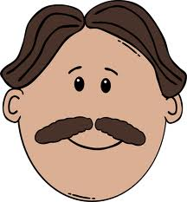 | Tarō Hashimoto | Hiro Yamada | Jo Suzuki
Nihon  Tōkyō  enjinia  shujin | Ōsutoraria  Meruborun  kaishain  tomodachi | Ōsutoraria  Meruborun  gakusei  kareshi | Igirisu  Manchesutā  shufu  tomodachi
Yūki Ogawa  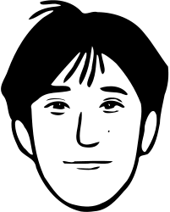 | Midori Suzuki | Yasuko Mori | Sachiko Smith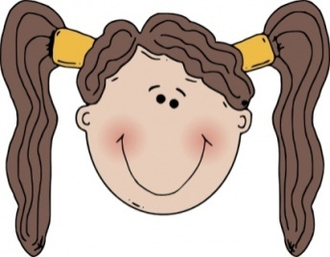
Nihon  Kyōto  gakusei  shujin | Ōsutoraria  Meruborun  shufu  tomodachi | Nihon  Kyōto  shufu  kanai | Nihon  Tōkyō  kaishain  kanai

