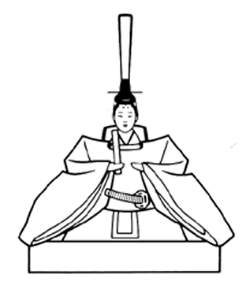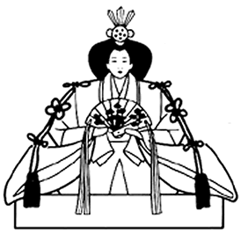
Hina matsuri
third day of the third month

Dolls Festival 3rd March

This festival is to pray for young girl’s growth and happiness. On the third of March for more than 1200 years, families with girls will display special dolls called hina ningyo. These dolls can be very expensive and are usually passed down from generation to generation. Another festival called Momo no sekku or Peach Festival is also held at this time as the peach trees are in bloom.
A few days before the festival mothers and girls will set up the red tiered shelf called the hina dan. The top shelf will hold the Emperor on the left and the Empress on the right. The imperial dolls will sit in front of a gold folding screen, with the Emperor holding a ritual baton and the Empress a fan. Between the two figures would be sanboo kazari, two vases of artificial peach branches. The dolls will be dressed in beautiful Kyoto Heian court costumes. The Empress will be wearing the juuni hitoe or twelve-layered ceremonial robe.
The second tier will display the sannin kanjo, these court ladies hold equipment for serving sake, or rice wine. The third platform holds the musicians called gonin bayashi. The five musicians could be holding a small drum, taiko, a large drum, ootsuzumi, a hand drum, kotsuzumi, a flute, fue, and the singer will be holding a fan, sensu.
The fourth tier will have the younger Minister of the Right, udaijin, and the older Minister of the Left, sadaijin. Each of these figures will be holding bow and arrows. On the fifth tier, beneath the Minister of the Right, will be a mandarin orange tree, ukon no tachibana, and beneath the Minister of the Right will be a cherry blossom tree, sakon no sakura. Also on the fifth tier will three samurai. One will represent the sad drinker, one the angry drinker and one the merry drinker.
Some displays may have seven tiers and these will contain miniature furniture, for example a chest of drawers, a kimono chest, smaller storage boxes, a mirror stand, sewing kit box, utensils for the tea ceremony, boxes for food, an ox-drawn carriage as well as other items.
Many people collect dolls, or hina. Three Japanese men, referred to as the three great toy collectors, began collecting ningyo dolls in an effort to document and preserve these dolls. Nowdays collections of ningyo can be found in museums.
Like many festivals, superstitions also exist for this festival. One superstition says that leaving the ningyo dolls out for too long after the 3rd of March will mean that the daughter will marry when she is older. Another is that the sins, or bad fortunes, of the girls can be passed to paper dolls, nagashi bina, which are then thrown into a body of water or burned, thus taking away the girls’ sins. This tradition still exists in some areas of Japan where paper dolls are put into rivers. Monks from the Shinto shrines will collect these paper dolls from the river and then later burn them at the shrine.
Even the food shows some superstition. Diamond-shaped rice cakes, called hishimochi, are eaten during this festival. They are a layered rice cake, the red or pink layer is to chase away evil spirits, the white layer is for purity and the green layer is for health.

Questions
1. Practice your hiragana. Write these words in hiragana in the boxes.
a | Girl’s Festival | ひ | な | ま | つ | り
b | Special Dolls | ひ | な | に | ん | ぎょ
c | Tiered shelf | ひ | な | だ | ん
d | 12 layered ceremonial robe | じゅ | う | に | ひ | と | え
e | Three court ladies | さ | ん | に | ん | か | ん | じょ
f | Five musicians | ご | に | ん | ば | や | し
g | Small drum | た | い | こ
h | Large drum | お | お | つ | ず | み
i | Hand drum | こ | つ | ず | み
j | Fan | せ | ん | す

2. Answer the following questions in English.
a | What is the name of the Minister of the Right? | udaijin
b | What is underneath this minister? | Mandarin tree
c | Which level is this minister on? | Fourth level
d | What is the tree underneath the Minister of the Left? Write this in Japanese. | Cherry blossom tree, さこん の さくら
e | Who is on the fifth level? | Three samurai.
f | What is the Japanese name of the diamond shaped rice cakes eaten on 3 March? | Tearful drinker
g | Write the name for the rice cake in Japanese. | hishimochi
h | What does the green layer of the rice cake symbolise? | Good health
i | What is the name, Japanese and English, of the other festival celebrated around this time? | Momo no sekku,  Peach Festival
j | What other items might be on the hina dan?
Colour in these two Imperial figures.
Put your glue here.
NOTE: More information about this festival can be researched on the internet.
Questions Answers
1. Write these words in hiragana in the boxes.
a | Girl’s Festival | ひ | な | ま | つ | り
b | Special Dolls | ひ | な | に | ん | ぎょ
c | Tiered shelf | ひ | な | だ | ん
d | 12 layered ceremonial robe | じゅ | う | に | ひ | と | え
e | Three court ladies | さ | ん | に | ん | か | ん | じょ
f | Five musicians | ご | に | ん | ば | や | し
g | Small drum | た | い | こ
h | Large drum | お | お | つ | ず | み
i | Hand drum | こ | つ | ず | み
j | Fan | せ | ん | す

2. Answer the following questions in English.
a | What is the name of the Minister of the Right? | uduaijin
b | What is underneath this minister? | Mandarin orange tree
c | Which level is this minister on? | Fourth level
d | What is the tree underneath the Minister of the Left? Write this in Japanese. | Cherry blossom  さこん の さくら
e | Who is on the fifth level? | Three samurai.
f | What is the Japanese name of the diamond shaped rice cakes eaten on 3 March? | hishimochi
g | Write the name for the rice cake in Japanese. | ひしもち
h | What does the green layer of the rice cake symbolise? | Good health
i | What is the name, Japanese and English, of the other festival celebrated around this time? | Momo no sekku,  Peach Festival
j | What other items might be on the hina dan? | Pieces of furniture, a mirror stand, chest of drawers, etc
