一日に一回 How many times
- Frequency Expressions
You can describe the frequency of events over a period of time by using the following framework.

(time period) に (frequency) (frequency) per (period)
ni

一日 に 一回 once a day
Ichinichi ni ikkai

一週間 に 二回 twice a week
Isshukan ni nikai

一ヶ月 に 三回 three times a month
Ikkagetsu ni sankai

一年 に 四回 four times a year
Ichinen ni yonkai

- Adverbs
Adverbs are sometimes used with frequency expressions.

In negative sentences | In affirmative sentences
ぜんぜん ＋ negative  zen zen ( =never)  あまり＋ negative  Amari (=not much) | ときどき  Tokidoki ( =sometimes)  よく  Yoku (=often)  毎日  Mainichi (=everyday)

- Asking questions
When making question sentences using frequency expressions, you fill “nan” in the parentheses ( ) as in the following examples.
一日 に ( )回  Ichinichi ni ( )kai (# a day)  一週間 に ( )回  Isshukan ni ( )kai (# a week)  一ヶ月 に ( )回  ikkagetsu ni ( )kai (# a month)  一年 に ( )回  Ichinen ni ( )kai (# a year) | 一日に何回  Ichinichi ni nankai  How many times a day

Q: 一日に何回食べますか。
Ichinichi ni nankai tabemasuka. How many times a day do you eat?

A: 一日に二回食べます。
Ichinichi ni nikai tabemasu . I eat twice a day.

朝はぜんぜん食べません。
asa wa zenzen tabemasen. I never eat breakfast.

Q: 一週間に何回そうじしますか。
Isshuukan ni nankai souji shimasuka. How many times a week do you clean your house?

A: あまりそうじしません。
Amari souji shimasen. I don’t clean my house much.
一ヶ月に一回ぐらいそうじします。
Ikkagetsu ni ikkai gurai souji shimasu. I clean my house about once a month.

Q: よく映画を見ますか。
Yoku eiga o mimasuka. Do you often watch movies?

A: 一ヶ月に二回ぐらい映画を見ます。
Ikkagetsu ni nikai gurai eiga o mimasu. I watch movies about twice a month.

- Pair Work (Questionnaire)
One of you is the doctor, and the other is the patient. The doctor will ask the questions using frequency expressions and adverbs. The patient will answer the questions.

Examples:
Doctor: よくうんどうしますか。 一週間に何回うんどうしますか。
Yoku undoo shimasuka. Isshuukan ni nankai undoo shimasuka.
Do you often do physical exercise? How many times a week do you do physical exercise?

Patient: あまりうんどうしません。 一ヶ月に一回ぐらいうんどうします。
Amari undoo shimasen. Ikkagetsu ni ikkai gurai undoo shimasu.
I don’t do much physical exercise. I do physical exercise about once a month.

Questions | Answers
Daily Activities
一日に何回…
Ichinichi ni nankai…
How many times a day…
トイレ
Toire ni ikimasu ka.
Do you go to the bathroom?
歯
Ha o migakimasu ka.
Do you brush your teeth?
Weekly Activities
一週間に何回…
Isshuukan ni nankai…
How many times a week…
お酒
Osake o nomimasu ka.
Do you drink alcohol?
肉
Niku o tabemasu ka.
Do you eat meat?
やさいやくだもの
Yasai ya kudamono o tabemasu ka.
Do you eat vegetables and fruits?

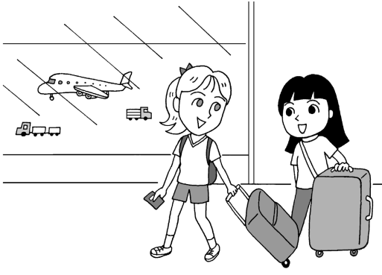
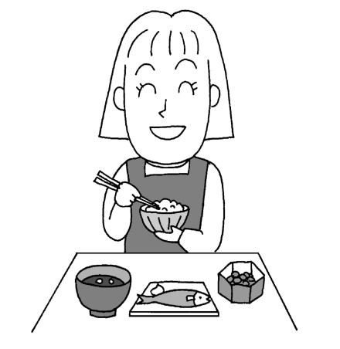
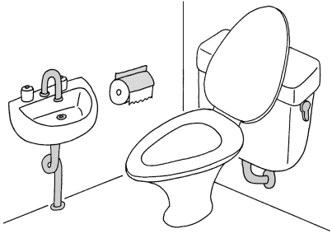
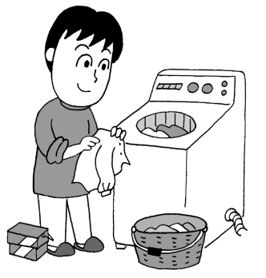
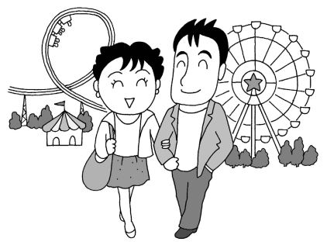
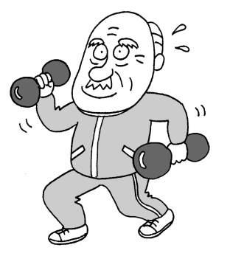
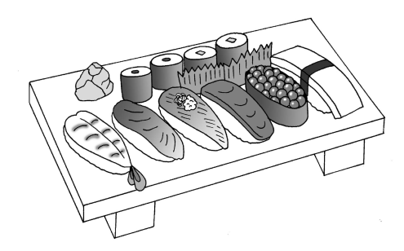
6. once a year
4. once a month
5. Twice a month
Ex. twice a day
1. four times a day
2. once a week
3. twice a week
Example:
一日に二回食べます。
Ichinichi ni nikai tabemasu.
I eat twice a day.
Look at the following pictures and make sentences as in the example.
Vocabulary
tabemasu to eat
toire ni ikimasu to go to a bathroom
undoo shimasu to do physical exercises
sentaku shimasu to do laundry
sushi o tabemasu to eat sushi
deeto shimasu to have a date
ryokoo shimasu to travel

