**Janken ジャンケン: rock scissors papers**

**Jan ken pon! Aiko deshou!**

**Goo Choki Paa**

 　　　　 　　　

**ishi : rock hasami: scissors kami: paper**

**Katta!!　　 : Win!!**

**Maketa…　　　：Lose…**

**Aiko : Draw**

**Kakurenbo no uta♪　Hide and seek song**

|  |  |
| --- | --- |
| **Kakurenbo suru mono**  **Yottoide**  **Jyanken pon de**  **Aiko de syo!!**  **Mou iikai?**  **Mada da yo.**  **Mou iikai?**  **Mou iiyo.** | **Come and gather those who want to do hide and seek**  **Rock and scissor and paper,123!!**  **Are you ready?**  **Not yet!**  **Are you ready?**  **Yes, OK!!** |

**Goo Choki Paa no uta♪**

|  |  |
| --- | --- |
| **Goo Choki Paa de**  **Goo Choki Paa de**  **Nani tsuku rou?**  **Nani tsuku rou?**  **Migi te ga paa de**  **Hidari te mo paa de**  **Choucho**  **Choucho** | **Rock, scissors and paper**  **Rock, scissors and paper**  **What shall we make with them**  **What shall we make with them**  **Right hand is paper**  **Left hand is paper too**  **(Then, we can make a)**  **Butterfly**  **Butterfly** |



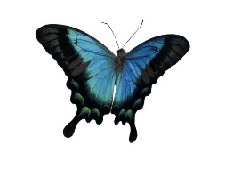**ちょうちょ butterfly**

**かにさん　crab**

**かたつむり　snail**

**くまさん　bear**

**おにぎり　rice ball**

**ゆきだるま　snowman**

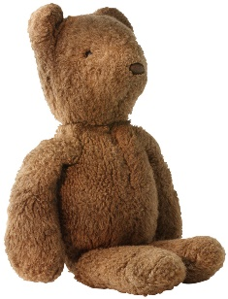**たこさん　octopus**

[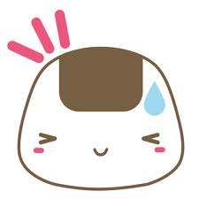](http://www.google.com.au/imgres?sa=X&biw=1920&bih=955&tbm=isch&tbnid=WD4CUXbXjZegLM:&imgrefurl=http://www.deviantart.com/morelikethis/artists/70002090?view_mode=2&docid=ZhxDry_YkIOb6M&imgurl=http://fc06.deviantart.net/fs17/f/2007/154/3/8/Onigiri_Hot_Hot_by_amaitokyo.png&w=600&h=600&ei=KuSOUu7sEMSukgXL0IHYDg&zoom=1&ved=1t:3588,r:27,s:0,i:178&iact=rc&page=1&tbnh=183&tbnw=177&start=0&ndsp=31&tx=121&ty=130)****