Japanese Places
Can you label the numbered places with the correct names? Have a go and see how many you can get. (Write your answers in the box below next to the corresponding answers.)
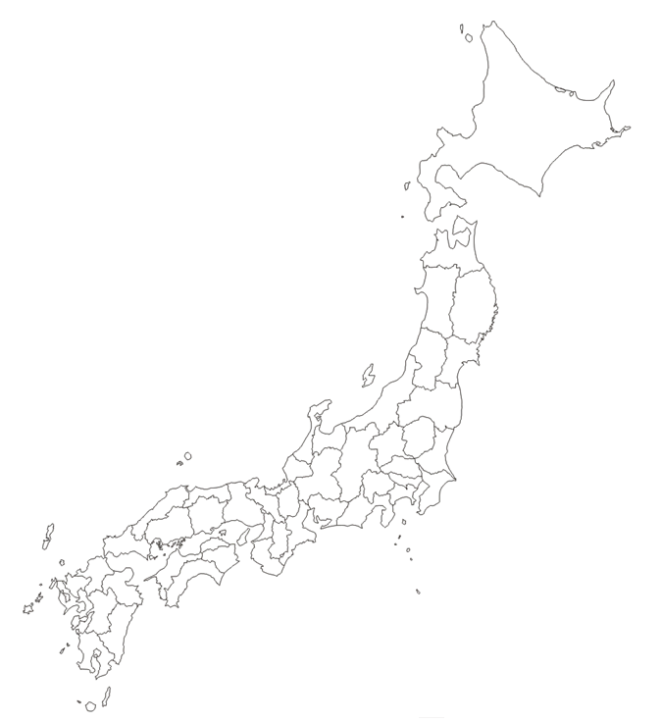
7

6

5

2
8

9

4

1
3

1. _____________________ 4. _____________________ 7. _____________________

2. _____________________ 5. _____________________ 8. _____________________

3. _____________________ 6. _____________________ 9. _____________________

