Japanese Islands

Have a look at the map below. There are 5 main islands in Japan. Can you name all of them?
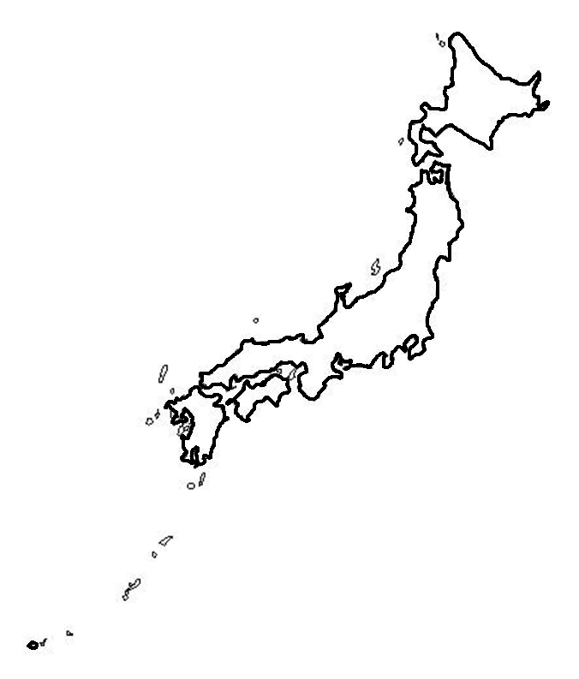
4. _____________________________

1. _____________________________

3. _____________________________

2. _____________________________

5. _____________________________

