Kasajizoo - The Bamboo Hatted Statues
- Read the story of Kasajizoo at http://web-japan.org/kidsweb/folk/kasajizo/index.html
Then answer these questions.
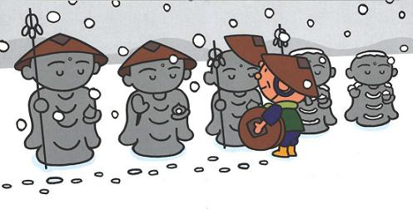
1. At what time of year is this story set?
______________________________________
2. What did Ojiisan decide to do so that he could have rice cakes to eat?
____________________________________________________________________________
3. How did Ojiisan feel when he couldn't sell any of the hats?
____________________________________________________________
4. The stone statues of Jizo are said to be the protector of children or animals?
____________________________________________________________
5. When Ojiisan saw the Jizo statues covered in snow, what did he do?
____________________________________________________________
6. Was Obaasan angry with Ojiisan?
____________________________________________________________
7. What was the noise in the middle of the night?
____________________________________________________________
- Put the following parts of the story in the correct order.
Ojiisan and Obaasan ate the rice cake on New Year's Day.
Ojiisan placed the hats onto the Jizo statues.
The Jizo statues had left them gifts to thank Ojiisan for being so kind.
Once upon a time, there lived a very poor Ojiisan and Obaasan.
Ojiisan didn't sell any hats, and went on his way home feeling sad.
Ojiisan went to market to sell the bamboo hats.
In the middle of the night, Ojiisan and Obaasan heard strange noises at their door.

