わたしの 一日
なまえ：＿＿＿＿＿＿＿＿＿＿
My Day

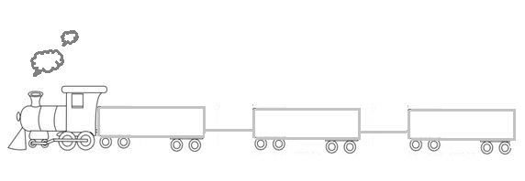
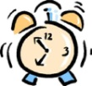 Can you help the (passenger) to get onto the train in the correct order? Remember to have particles (は、を、に) on the connecting chains! (Reminder: STOPTV rule!!)
１．（おきます） （マリさん）（あさ 六時半）
おきます。
に
は
マリさん
あさ 六時半
２．（ねます） （ナタリアさん）（よる 十二時）

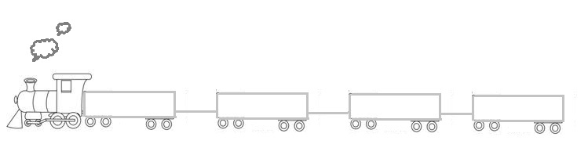
３．（ききます） （ともこさん）（おんがく）（ゆうがた 五時）

４．（みます）（けんたさん）（よる 七時）（テレビ）

[键入文档的引述或关注点的摘要。您可将文本框放置在文档中的任何位置。可使用“文本框工具”选项卡更改重要引述文本框的格式。]
[键入文档的引述或关注点的摘要。您可将文本框放置在文档中的任何位置。可使用“文本框工具”选项卡更改重要引述文本框的格式。]
４．（みます） （リリアンさん） (テレビ) （よる 十時）
６．Make your own Train!!
５．（いきます）（わたしたち）（日ようび）（ともだちの いえ）

