なん人いますか
Survey your classmates about how many people are in their families. Speak only in Japanese! Write their name in the column with the correct number of people for their family.
一人 | 二人 | 三人 | 四人 | 五人 | 六人 | 七人 | 八人 | 九人 | 十人
 |  |  |  |  |  |  |  | 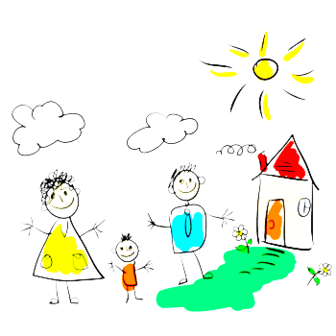
Qごかぞくはなんにんいますか。 Aかぞくは＿＿にんいます。

