|  |  |  |  |  |  |  |
| --- | --- | --- | --- | --- | --- | --- |
| **➀** | **一** |  | **一** | **一** | **一** | **一** |
| **➁** | **二** |  | **二** | **二** | **二** | **二** |
| **➂** | **三** |  | **三** | **三** | **三** | **三** |
| **➃** | **四** |  | **四** | **四** | **四** | **四** |
| **➄** | **五** |  | **五** | **五** | **五** | **五** |
| **➅** | **六** |  | **六** | **六** | **六** | **六** |
| **➆** | **七** |  | **七** | **七** | **七** | **七** |
| **➇** | **八** |  | **八** | **八** | **八** | **八** |
| **➈** | **九** |  | **九** | **九** | **九** | **九** |
| **➉** | **十** |  | **十** | **十** | **十** | **十** |

**\*\*For numbers between 10 and 19:** Put the symbol for ‘10’ first, then the units *(e.g. 1 – 9)*.

**Example:** 14 = 十四  *(juu yon)*

**\*\*For numbers 20 - 99:** Write the number of tens, then the symbol for ‘10’, then the units

**Example 1:** 36 = 三十六 *(san juu roku)*

**Example 2:** 50 = 五十 *(go juu)*

**Let’s try!**

22 ____________ 37 _____________ 90 　 _____________

18 ____________ 四十 ____________ 八十六 ____________

十五 ____________ 七十六 ____________ 五十一 ____________

**TASK:** Write the answer to the following mathematical sums in KANJI

**１．** 六　＋　八　＝　＿＿＿　**２．**四　－　二　＝　＿＿＿　**３．**九　÷　三　＝　＿＿＿

**４．**九　ｘ　四　＝　＿＿＿ **５．**七　－　一　＝　＿＿＿　**６．**八　＋　十一　＝　＿＿_

**７．**六十五　－　三十　＝　＿＿＿＿ **８．**二十一　÷　三　＝　＿＿＿＿

**９．**四十四　ｘ　二　＝　＿＿＿ **１０．**四十八　　÷　六　＝　＿＿＿＿＿

**TASK 3:** Fill in the missing numbers in each sequence in KANJI

**１．**十六、三十二、＿＿＿＿＿、六十四、＿＿＿＿、九十六 …

**２．**一、二、＿＿＿、八、＿＿＿、三十二、＿＿＿＿ …

**３．**五、十、＿＿＿＿、二十、＿＿＿＿＿、＿＿＿＿＿、三十五、四十、＿＿＿＿＿＿…

★★★★★★★★★★★★★★★★★★★★★★★★★★★★★★★★★★★★★★★★★

！

**Game 1:** White grid – Numbers in English **Game 2:** Shaded grid – Numbers in Kanji

|  |  |  |  |  |  |
| --- | --- | --- | --- | --- | --- |
|  |  |  |  |  |  |
|  |  |  |  |  |  |
|  |  |  |  |  |  |

Asking age (Q):　　 　　。

Stating my age (A):　 NUMBER IN JAPANESE 　。

**Practice the kanji:**

|  |  |  |  |  |  |  |
| --- | --- | --- | --- | --- | --- | --- |
| **Age**  *Looks like a person with a walking stick* |  |  |  |  |  |  |
|  |  |  |  |  |  |

**Fill in the gaps in the sentence in Japanese so it matches with the English translation below:**

**Example:**　　＿＿＿＿　　。George is 24 years old.

**1.** 　　＿＿＿＿　　。Hannah is 37 years old.

**2.** 　　十三　______　。Tony is 13 years old.

**3.** 　　＿＿______＿＿　_______　。Cameron is 52 years old.

**Interview your classmates using the dialogue above. Note using a Japanese tally how many people are these ages:**

|  |  |  |
| --- | --- | --- |
|  |  |  |
|  |  |  |

**Japanese Schooling System**

There are **4 levels** of schooling in Japan - elementary school, junior high, senior high and university. This system was adopted from the American system after their occupation after WWII. The competition is fierce in Japanese schools with some elite elementary schools even requiring students to sit an exam to gain entry. The standard of education is high in Japan and there is a lot of pressure on students to succeed.

|  |  |  |  |  |
| --- | --- | --- | --- | --- |
| **LEVEL** | Kanji/Hiragana | *Romaji* | Memory Trick | **Other information** |
| **Elementary school** | 小学 | *shou gaku* | Short people | **Grades 1-6; Ages 6-11** |
| **Junior high/middle school** | 中学 | *chuu gaku* | Rebels chew gum | **Grades 1-3; Ages 12-14** |
| **Senior high** | こうこう | *kou kou* | Double hard core | **Grades 1-3; Ages 15-17** |
| **University** | 大学 | *dai gaku* | Can dye your hair | **Grades 1-4; Ages 18+** |

**Practice the kanji** (your teacher will show you the stroke order):

|  |  |  |  |  |  |  |
| --- | --- | --- | --- | --- | --- | --- |
| **Elementary**  *Looks like a short person jumping* |  |  |  |  |  |  |
|  |  |  |  |  |  |

|  |  |  |  |  |  |  |
| --- | --- | --- | --- | --- | --- | --- |
| **Junior High**  *A line is through the middle* |  |  |  |  |  |  |
|  |  |  |  |  |  |

|  |  |  |  |  |  |  |
| --- | --- | --- | --- | --- | --- | --- |
| **Senior High**  *First two characters are doubled* |  |  |  |  |  |  |
|  |  |  |  |  |  |

|  |  |  |  |  |  |  |
| --- | --- | --- | --- | --- | --- | --- |
| **University**  *Looks like a big person - adult* |  |  |  |  |  |  |
|  |  |  |  |  |  |

**NEW GRAMMAR: Stating your grade**

Asking grade (Q):　　 　　。

Stating my grade (A):　 LEVEL + NUMBER IN JAPANESE 　。

**Your sentence: ___________________________________________________**

**Task 1:** Listen carefully and record the students’ age and year levels.

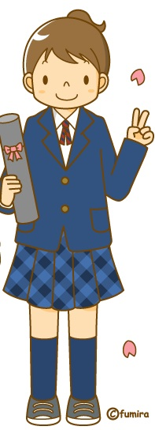

|  |  |  |
| --- | --- | --- |
| **➊** | **Age:** | **Year:** |
| **➋** | **Age:** | **Year:** |
| **➌** | **Age:** | **Year:** |
| **➍** | **Age:** | **Year:** |
| **➎** | **Age:** | **Year:** |

**Task 2:** True or False? Does the English match the Japanese? If false, circle what is incorrect in the Japanese sentence.

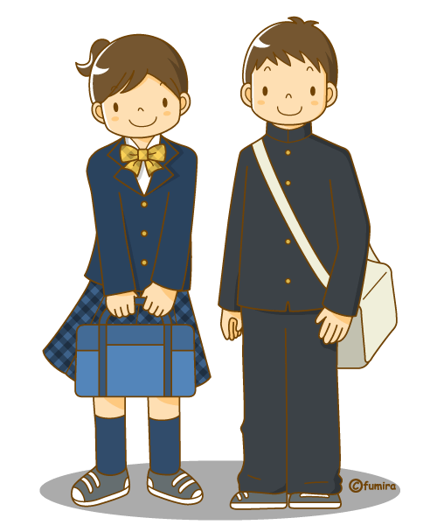

1. 　は　こうこう　二　ねんせい　です。

I am in the second grade of Senior High. **TRUE/FALSE**

2.　　は　大学　四　ねんせい　です。

Takeshi is in the first year of university. **TRUE/FALSE**

3.　　は　中学　五　ねんせい　です。

I am in the Year 5 (elementary school). **TRUE/FALSE**

4.　　は　中学　六　ねんせい　です。

Rina is in her third year of Junior High. **TRUE/FALSE**



**Finished?** Use your laptop to try these sites: <http://www.digitaldialects.com/Japanese/numbers_1B.htm> and <http://www.digitaldialects.com/Japanese/numbers_1B_KS.htm>