これ は「おんみょうざ」です。おんみょうざ は
ヘヴイメタルバンド です。おさか から です。
くろねこ は リードボーカル です。
たんじょうび は7月16 日です。おどる こと
が 好き です。うつくしくて、
しんせつな ひと です。
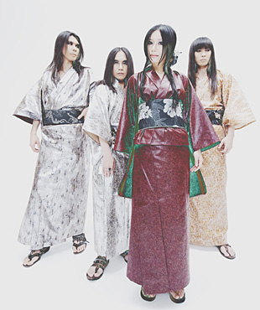
http://www.onmyo-za.net/index.html

- What’s the name of the band? (Use your hiragana chart to help you.)
_____________________________________________________________

- What type of music does this band play?
_____________________________________________________________

- What part of Japan are they from?
_____________________________________________________________

- Who is Kuroneko?
_____________________________________________________________

- When is Kuroneko’s birthday?
_____________________________________________________________

- What does she like to do?
_____________________________________________________________

- What type of person is Kuroneko? (There may be more than one answer.)
- funny b. beautiful b. cool c. kind e. cute

- Listen to the band play ‘Aoki Dokugan’ (The blue one eyed - a tribute to Date Masamune, a famous one-eyed samurai commonly depicted wearing blue armour.) Did you like it?

