お正月 おしょうがつ Oshōgatsu
In Japan there are a variety of customs and events in the New Year period. Look at the traditions below. Match the pictures with their Japanese.
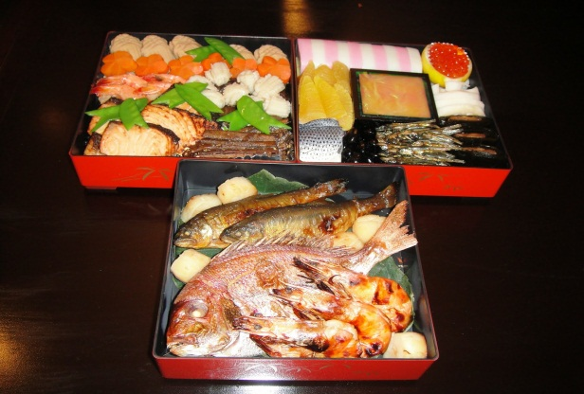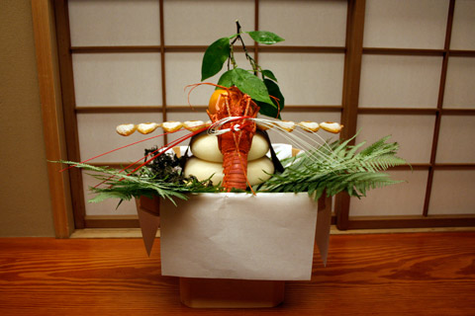
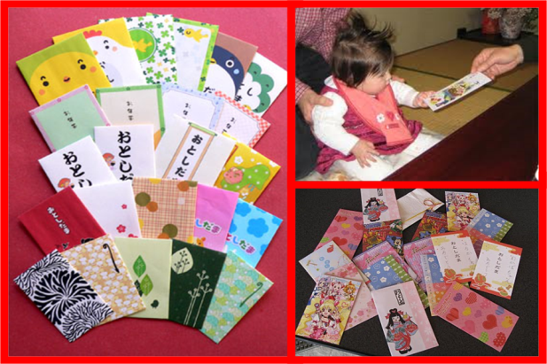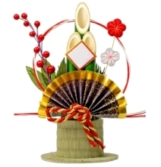
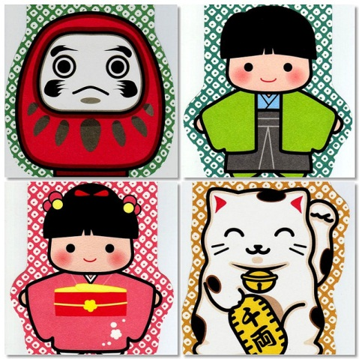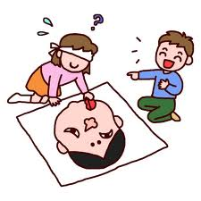
Cut out the words below and glue them underneath the corresponding picture.
かどまつ Kadomatsu ねんがじょ Nengajyo
おせちりょうり Osechiriyouri おとしだま Otoshidama
かがみ もち Kagami Mochi ふくわらい Fukuwarai

