Pets

1. Join the pictures with the words.

hebi へび tori とり kame かめ usagi うさぎ

nezumi ねずみ inu いぬ neko ねこ sakana さかな

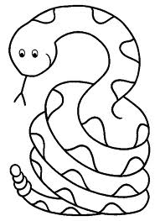

2. Fill in the missing hiragana by choosing a hiragana from the list.
か ka あ a
き ki い i
く ku う u
け ke え e
こ ko お o

rabbit __さぎ
cat ね__
fish さ__な
turtle __め
dog __ぬ

3. Draw a picture of the following pets.

usagi
tori
hebi

