**PLACES**

**Place　に/へ　いきます。**

[](http://www.shutterstock.com/subscribe.mhtml)

[](http://www.google.com.au/imgres?imgurl=http://www.dreamstime.com/cartoon-house-thumb16120661.jpg&imgrefurl=http://www.dreamstime.com/stock-image-stock-image-cartoon-house-image16120661&usg=__sL2dnGM2-nkVhhXbI1Z-X6_VnG8=&h=340&w=400&sz=35&hl=en&start=4&sig2=ST9r_O-tvwSLCWoXflShvw&zoom=1&tbnid=oeAUM4J7LYYbLM:&tbnh=105&tbnw=124&ei=XoO5T_CGIemViQfoutiQCQ&prev=/search?q=cartoon+home&um=1&hl=en&gbv=2&complete=0&tbm=isch&um=1&itbs=1)[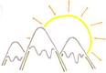](http://www.aperfectworld.org/clipart/nature/cartoon_mountains.png)

うち

がっこう

やま

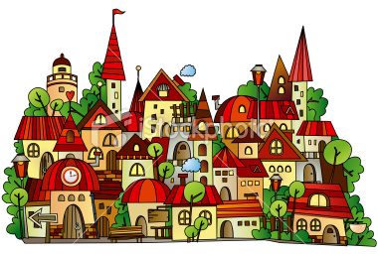

[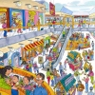](http://picture-book.com/files/userimages/1156u/mall-shortcuts3.jpg)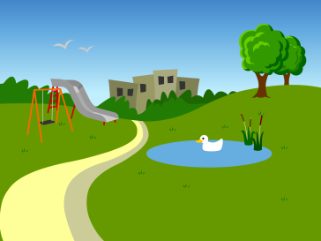

こうえん

まち

モール

[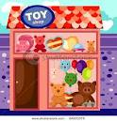](http://www.google.com.au/imgres?imgurl=http://image.shutterstock.com/display_pic_with_logo/553351/553351,1288615949,2/stock-vector-illustration-of-cartoon-toy-shop-64153375.jpg&imgrefurl=http://www.shutterstock.com/pic-64153375/stock-vector-illustration-of-cartoon-toy-shop.html&usg=__q8lEwL6sGms9yoorwc5UeKToOzc=&h=470&w=450&sz=65&hl=en&start=14&sig2=4y8SmcpKsjY9YCyY2RS4qw&zoom=1&tbnid=8jo2ZN-GjqeUfM:&tbnh=129&tbnw=124&ei=w4S5T6r2C4WPiAfw_OTyCA&prev=/search?q=cartoon+shop&um=1&hl=en&gbv=2&complete=0&tbm=isch&um=1&itbs=1)[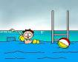](http://www.google.com.au/imgres?imgurl=http://www.artie.com/summer/arg-kid-in-pool-w-shark-bg-207x165-url.gif&imgrefurl=http://www.artie.com/summer/&usg=__376-eUzJn-zCv8ZaADZ10G1HphE=&h=165&w=207&sz=45&hl=en&start=3&sig2=8ckAnnAW7I2jVVww_FWXew&zoom=1&tbnid=R7P5URc3bEjEnM:&tbnh=84&tbnw=105&ei=54S5T-rpOKWSiAf3mfGJCQ&prev=/search?q=cartoon+pool&um=1&hl=en&gbv=2&complete=0&tbm=isch&um=1&itbs=1)[](http://www.google.com.au/imgres?imgurl=http://www.how-to-draw-cartoons-online.com/image-files/cartoon-beach-8.gif&imgrefurl=http://www.how-to-draw-cartoons-online.com/cartoon-beach.html&usg=__tE00xhRIGJMt2pjw5OMRQCf6AtI=&h=411&w=540&sz=22&hl=en&start=1&sig2=7snDzxft3j6U6Gvy69r4oQ&zoom=1&tbnid=ZqSF9UGrRoPleM:&tbnh=100&tbnw=132&ei=dIO5T4XzKamZiAfh9M33CA&prev=/search?q=cartoon+beach&um=1&hl=en&gbv=2&complete=0&tbm=isch&um=1&itbs=1)

プール

うみ

みせ

[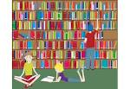](http://www.google.com.au/imgres?imgurl=http://www.wordsworthreading.co.uk/blog/wp-content/uploads/2012/01/cartoon-library.jpg&imgrefurl=http://www.wordsworthreading.co.uk/blog/?p=802&usg=__nkcZ4FLX40PiuqIG8iVWtyNF9KY=&h=722&w=1050&sz=578&hl=en&start=1&sig2=PM5aFoYkc7azvVdISE3Nbw&zoom=1&tbnid=gvsLhSryMKySIM:&tbnh=103&tbnw=150&ei=eIW5T43pKe-UiQeCwtjUCA&prev=/search?q=cartoon+library&um=1&hl=en&gbv=2&complete=0&tbm=isch&um=1&itbs=1)[](http://www.google.com.au/imgres?imgurl=http://www.vector-eps.com/wp-content/gallery/cartoon-farm-vectors/cartoon-farm-vector1.jpg&imgrefurl=http://www.vector-eps.com/index.php/2011/01/cartoon-farm-vectors/&usg=__Sv8if-K1sz0W8VO9odhMOeEcrHo=&h=344&w=500&sz=44&hl=en&start=1&sig2=2VraJpH1B91c__WXwHZb8Q&zoom=1&tbnid=I09pChNvUpsKsM:&tbnh=89&tbnw=130&ei=R4W5T5CsG4auiQfopoWQCQ&prev=/search?q=cartoon+farm&um=1&hl=en&gbv=2&complete=0&tbm=isch&um=1&itbs=1)[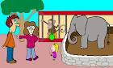](http://www.google.com.au/imgres?imgurl=http://home.sprynet.com/~knduffy/zoo.gif&imgrefurl=http://home.sprynet.com/~knduffy/cartoons.htm&usg=__gi2QKtAMEFZXkQnKcwS_mFmfc8Q=&h=420&w=700&sz=53&hl=en&start=7&sig2=i6A4cn_SjZoIbO7ha_TQcg&zoom=1&tbnid=2-2SFusnot8BAM:&tbnh=84&tbnw=140&ei=G4W5T_T0JMieiAfQtrjzCA&prev=/search?q=cartoon+zoo&um=1&hl=en&gbv=2&complete=0&tbm=isch&um=1&itbs=1)

としょかん

のうじょう

どうぶつえん

[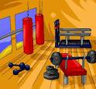](http://www.google.com.au/imgres?imgurl=http://3.bp.blogspot.com/-3t6j5wMdS-Q/ThzHgaAlCRI/AAAAAAAAAAM/M_ZxBUIAUmw/s1600/cartoon+gym.gif&imgrefurl=http://exerciseforhlth.blogspot.com/&usg=__rejELyH2TJdZQHOfMou8BHPfug8=&h=368&w=400&sz=38&hl=en&start=2&sig2=XfI-vl48c1cniz6S2BtRNg&zoom=1&tbnid=AtEPNdGkmbNE8M:&tbnh=114&tbnw=124&ei=AYe5T9_sBfCZiAfSp-yJCQ&prev=/search?q=cartoon+gym&um=1&hl=en&gbv=2&complete=0&tbm=isch&um=1&itbs=1)[](http://www.google.com.au/imgres?imgurl=http://images.crestock.com/2220000-2229999/2226585-xs.jpg&imgrefurl=http://www.crestock.com/image/2226585-Bad-Movie-Experience.aspx&usg=__T3IQRY6st6tsLa2MoZsk98ckCfU=&h=247&w=340&sz=41&hl=en&start=4&sig2=elNFHDFNpDr6AFsoMeEu4g&zoom=1&tbnid=-P3yGlWbFT1LQM:&tbnh=86&tbnw=119&ei=0oa5T-fHBOariAeI8bS8Dw&prev=/search?q=cartoon+cinema&um=1&hl=en&gbv=2&complete=0&tbm=isch&um=1&itbs=1)[](http://www.google.com.au/imgres?imgurl=http://www.aperfectworld.org/clipart/nature/river02.GIF&imgrefurl=http://www.aperfectworld.org/nature.html&usg=__8YITCv6tscbLgkg8D-7YbNSsR6E=&h=739&w=753&sz=33&hl=en&start=5&sig2=u8cGfs5phd-77OWBwvGflQ&zoom=1&tbnid=PukzqLkWA_-2qM:&tbnh=139&tbnw=142&ei=joa5T7bdDa6YiAfFsYnfCA&prev=/search?q=cartoon+river&um=1&hl=en&gbv=2&complete=0&tbm=isch&um=1&itbs=1)

えいがかん

かわ

たいいくかん