Sentence ORDER

Sentence pattern A
Going Places

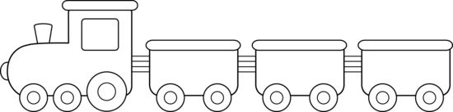
Person と
Verb。
Transport でで
Place に
Time に

Adjective？

Sentence pattern B
Doing something

Place で
Person と

Verb。
Noun を
Time に

Adjective？

