EXAMPLE SHOPPING DIALOGUE 1
Tenin = shop assistant Okyaku san = customer
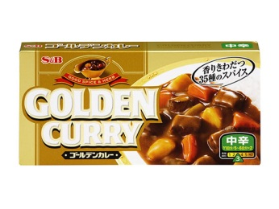
： Irrashaimase
おきゃくさん： Curry wa arimasu ka?
： Hai, kochira e doozo
(WALKS TO ITEM ON SHELF)
： Ikura desu ka?
(WALKS BACK TO REGISTER)
てんいん： Go hyaku en desu
： Hai, kore kudasai
(GIVES MONEY)
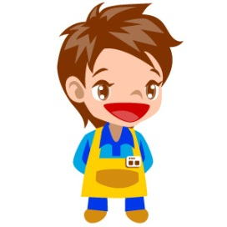
てんいん： Hai, sen en oazukari shimasu.
(COUNTS OUT CHANGE)
Go hyaku en okaeshi desu

： Doomo

： Arigatoo gozaimashita

Questions:
- What was the customer after? ____________________________________________
- How much was it? _____________________________________________________
- What money did the customer give the shop assistant? _________________________
- How much change was given? ____________________________________________
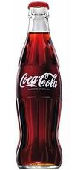
EXAMPLE SHOPPING DIALOGUE 2
Tenin = shop assistant Okyaku san = customer
(SHOP KEEPER IS BUSY – DOESN’T HEAR CUSTOMER COME IN)
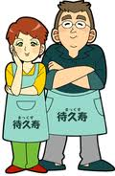
： Chotto sumimasen
： Hai, irrashaimase
： kokakoora ga arimasu ka?
： Hai, soko desu.
(POINTS TO ITEM NEARBY)
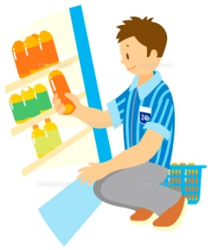
： (WALKS TO GET ITEM AND BRINGS BACK TO REGISTER)
： Hai, kore kudasai
(GIVES MONEY)
： Hai, go hyaku en oazukari shimasu.
(COUNTS OUT CHANGE)
San byaku ni juu en okaeshi desu

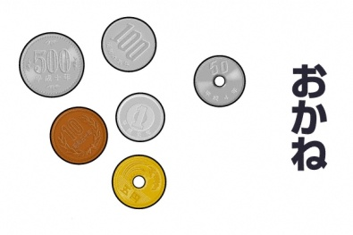
： Doomo

： Arigatoo gozaimashita

Questions:
- What was the customer after? ____________________________________________
- How much was it? _____________________________________________________
- What money did the customer give the shop assistant? _________________________
- How much change was given? ____________________________________________
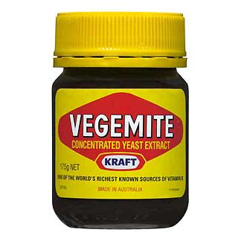
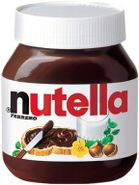
EXAMPLE SHOPPING DIALOGUE - 3
Tenin = shop assistant Okyaku san = customer
： irasshaimase
： bejemaito ga arimasu ka?
： bejemaito ga arimasen.
： nutella ga arimasu ka?
： hai, arimasu.
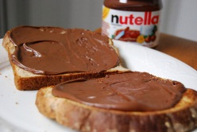
： nutella wa doko desu ka?
： soko desu.
： hai, wakarimashita。(Walks to item)
(Walks back to register.) kore kudasai.
： hai. (scans item) nana hyaku hachi juu en desu.
： (gives money to shop assistant)
： sen en oazukari shimasu.
(counts out change)
Ni hyaku ni juu en okaeshi desu.
： doomo.
： arigato gozaimashita.

Questions:
- What was the customer after? Any problems?________________________________
- How much was it? _____________________________________________________
- What money did the customer give the shop assistant? _________________________
- How much change was given? ____________________________________________

