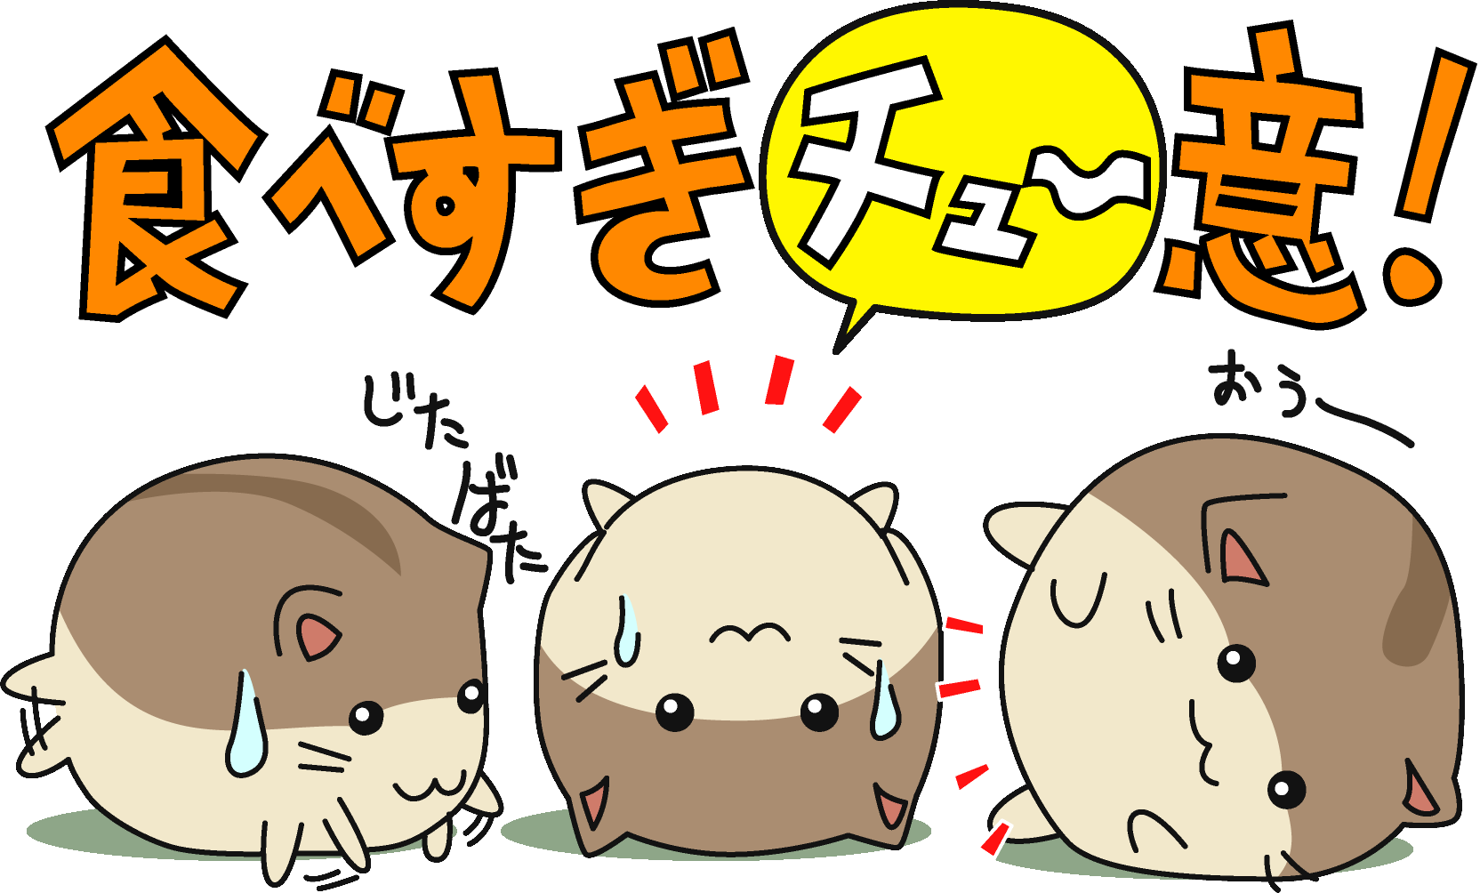
〜すぎ
Too Much of ……./in excess
This structure allows you describe when there is too much of something. This structure is made by adding 〜すぎ after verbs, い adjectives and な adjectives.
例：きのう、レストラン で ピザ を 食べすぎました。
I ate too much at the restaurant yesterday.
FORMATION
Remove the ます and replace with すぎる。
Vます ＋ すぎる ＝ 話し すぎる ＝talk too much

ADJ(い) ＋ すぎる ＝ 高 すぎる ＝too tall/expensive

ADJ（な） ＋ すぎる ＝ しずか すぎる ＝too quiet

Translate the following sentences into English.

- この つくえ は 私 の へや に 大きすぎる。（この- this)

____________________________________________________________________________________________________________________

- 今、先生 は いそがしすぎます。

＿＿＿＿＿＿＿＿＿＿＿＿＿＿＿＿＿＿＿＿＿＿＿＿＿＿＿＿＿＿＿＿＿＿＿＿＿＿＿＿＿＿＿

- 今日は、 ちっと はたらきすぎました。

＿＿＿＿＿＿＿＿＿＿＿＿＿＿＿＿＿＿＿＿＿＿＿＿＿＿＿＿＿＿＿＿＿＿＿＿＿＿＿＿＿＿＿

- この くつ は 小さすぎる。

＿＿＿＿＿＿＿＿＿＿＿＿＿＿＿＿＿＿＿＿＿＿＿＿＿＿＿＿＿＿＿＿＿＿＿＿＿＿＿＿＿＿＿

１．The dog is too noisy.

_____________________________________________________________________________________________________________________

2. Eating too much is not good.

____________________________________________________________________________________________________________________
****すぎcan also be used as a noun. For example,
Drinking too much beer is bad for you.
ビール を 飲みすぎ は よくありません／よくないです

