てform of verbs refresher て形の動詞の使う方

Group 1 Verbs (Godan verbs)
When changing verbs into te-form the sound that comes before masu is used to change it into another form. The sounds in group one often end with an ‘I’ sound
い,ち,り--->って
つかいます to use

つか
うたいます to sing

かいます to buy

たちます to stand

しゃしんを とります to take a photo

び,み,に--->んで
とび
とびます to jump or fly

のみます to drink

まなびます to study

あそびます to play
き--->いて
ある
あるきます to walk, go by foot

かきます to write or draw

ききます to listen

ぎ--->いで
およ
およぎます to swim
し--->して

はなします to speak

Group 2 verbs (ichidan verbs)
When changing group 2 verbs into te-form the masu is simply replaced by te. Most of the time an ‘e’ sound precedes masu in group 2 verbs but there are a few exceptions. Can you notice which ones do not follow the pattern?
みます--->みて
おきます--->おきて

みます to look/ see

たべます to eat

おしえます to teach

きます to get dressed

Irregular verbs
There are a few irregular verbs that do not follow either groups rule, for that reason these are called irregular verbs.
Examples;
いきます--->いって to go (somewhere)
きます--->きて to come (somewhere)

Irregular verbs also include verbs that preceded by two or more Chinese characters (kanji); when using these words as verbs we often add shimasu or shite this is because the words are often abstract nouns when used without the shimasu or shite ending. This is also applied when a verb is made from a foreign word using katakana.

勉強します to study

ダンスします to dance

Did you know:
Although some words are foreign loan words they have been put into Japanese verb groups by some clever Japanese people. So words like ‘Google’ as in to search for something on the popular search engine became ググる which is the plain form of the wordググります to search for something on Google, and if you were to use its te-form it would becomeググって. Another word that appears like this is ‘double’ or ダブる.
How and why is the te-form used? What makes it different from the polite masu?
A te-form verb used by itself is a command. However, there are a few more polite ways to use this conjugation. The te-form with the addition of kudasai can be used to ask someone to do something (unless they’re above you in social order then there is a further construction you will learn later), it can also be used to join two sentences together and you might have already used the te-form of adjectives to do this.
If you can’t remember the way to change the verb take a look at the previous pages:
Join these sentences using the te-form
例： 日本語を勉強します。本をよみます。
日本語を勉強して、本をよみます。
I studied, I read a book.
① テレビを見ます。＋ ラジオを聞きます。

② パスコンを使います。＋ しゅくだいを勉強します。

③ 高校へ行きます。+ 後でファッション・クラブへ行きました。

④ えをかきます。ことばをかきます。

Change these sentences into requests using the te-form plus 下さい:
例： 黒板を見ます。
(I) look at the blackboard.
黒板を見て下さい。
Please look at the blackboard.
歌を聞きます。

Please listen to a song
Listen to a song.
私に見ます。

Look at me.

ねます。
Sleep.
ドアを閉めます。

Close the door.

がんばります。
Do your best.

出ます。
To go out (somewhere).

外に行きます。

Go outside.

おきます。
To wake up.

Use three sentences that you have already learnt and transform them into the te-form:

- ________________________________________________________

- ________________________________________________________

- ________________________________________________________
What requests do you think these people are making?
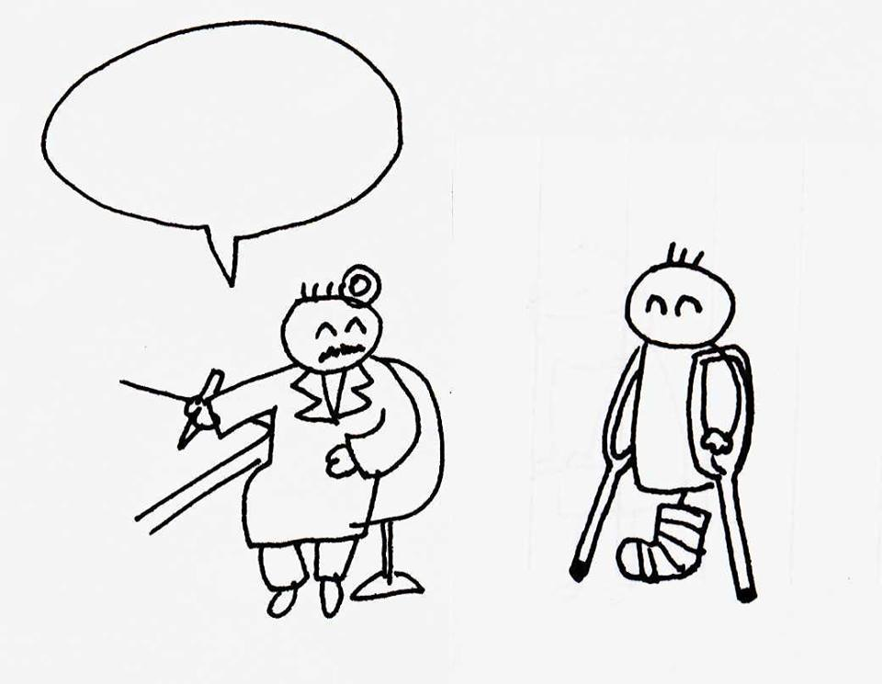
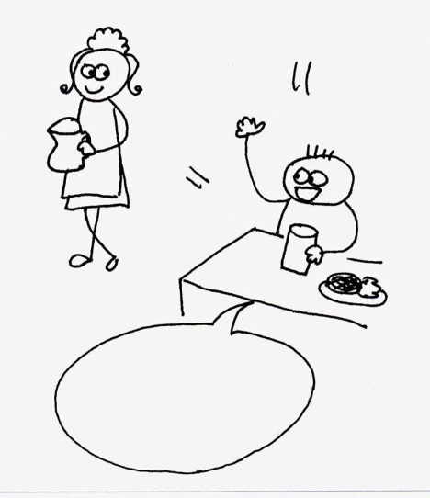
Look at the vocab page in your textbook if you’re having trouble

