Hiragana Rules
By adding ten ten “ or maru ^{O} you can make a range of new sounds. Just follow the rules below. Watch out for a few exceptions though!

K line (ka ki ku ke ko) | + ten ten “ is | G line (ga gi gu ge go)
S line (sa shi su se so) | + ten ten “ is | Z line (za *ji zu ze zo)
T line (ta chi tsu te to) | + ten ten “ is | D line (da *ji *zu de do)
H line (ha hi fu he ho) | + ten ten “ is | B line (ba bi bu be bo)
H line (ha hi fu he ho) | + maru ^{O} is | P line (pa pi pu pe po)
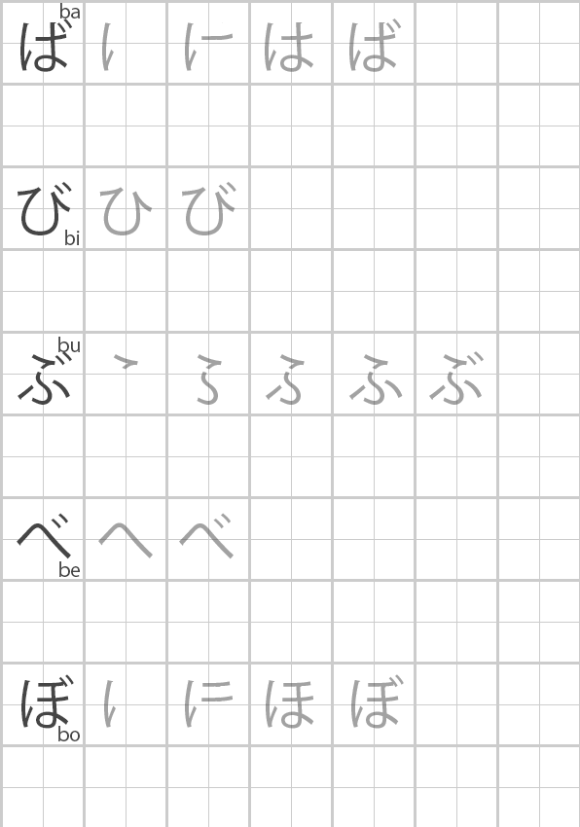
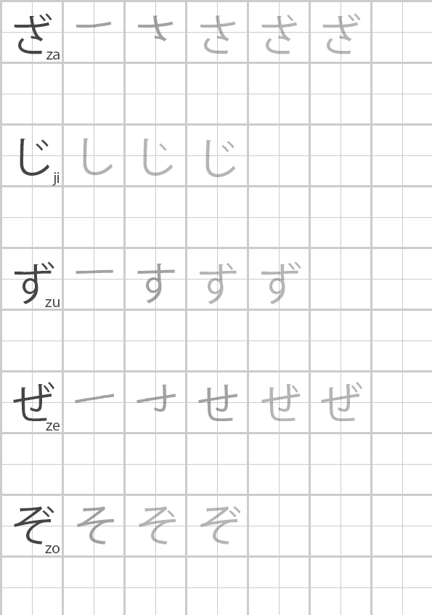
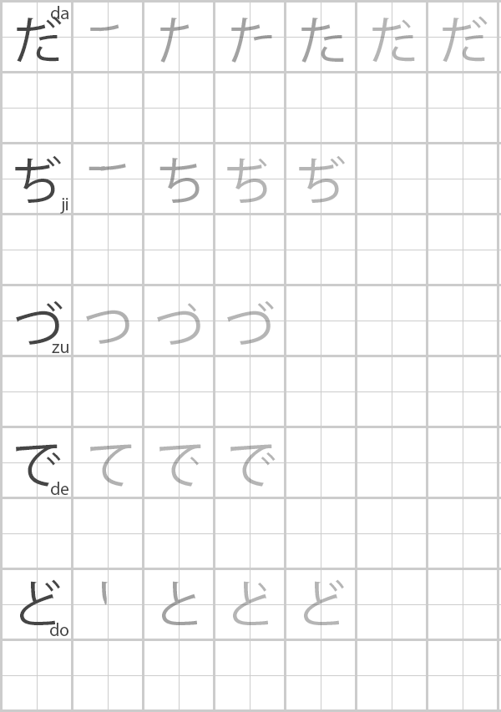
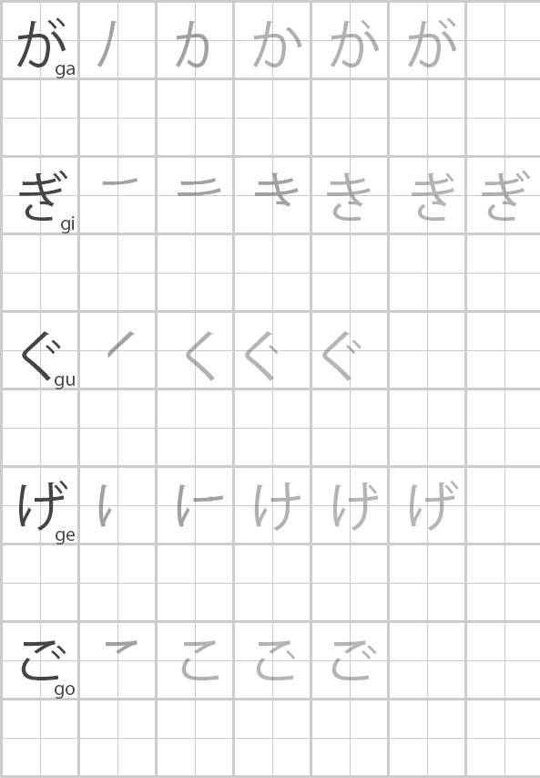

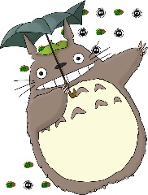
Hiragana Rules

K line (ka ki ku ke ko) | + ten ten “ is | G line (ga gi gu ge go)
S line (sa shi su se so) | + ten ten “ is | Z line (za *ji zu ze zo)
T line (ta chi tsu te to) | + ten ten “ is | D line (da *ji *zu de do)
H line (ha hi fu he ho) | + ten ten “ is | B line (ba bi bu be bo)
H line (ha hi fu he ho) | + maru ^{O} is | P line (pa pi pu pe po)

Test yourself by writing the correct hiragana:
Ga |  | Za |  | Do |  | Go
Da |  | Ji |  | Gi |  | Zo
Pa |  | De |  | Gu |  | Ba
Zu |  | Bi |  | Be |  | Po
Ze |  | Bu |  | Pu
Pe |  | Po |  | Ge

Try writing the following words in hiragana:
dentouteki (traditional)
kaban (bag)
empitsu (pencil)
usagi (rabbit)
midori (green)
manga (Japanese comic)
hiza (knees)
dare (who)
doyoubi (Saturday)
bunpou (grammar)
Zabuton (Japanese floor cushion)
Hiragana Rules
By adding a small つ (only half the usual size) before a hiragana character, you can create a double consonant (non-vowel) letter. When reading out a word with a small つ you don’t say the つ but instead leave a small pause or gap, as if you’re taking a tiny breath.

Let’s look at some examples:

が | っ | こ | う
- School – gakkou (pronounced ga_kkou)
This means leave a short pause here

き | っ | て
- Stamp - kitte (pronounced ki_tte)
Note that the small つ goes before the double letter

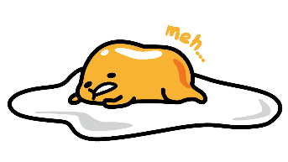
Now try some yourself:
Go | itte |  | い | っ | て
More | motto
Husband | otto
School Term | gakki
By far | zutto
Magazine | zasshi
4th Day | yokka
Wait | matte
Ticket | kippu
Suddenly | nutto
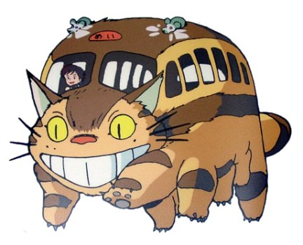

Now try writing the following classroom instructions:
Please sit | suwattekudasai
Please stand | tattekudasai
Please say | ittekudasai
Please do your best | ganbattekudasai

Hiragana Rules
By adding a small や ゆ or よ to a character we can make a whole range of new sounds. Check out the table below.

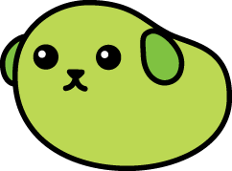
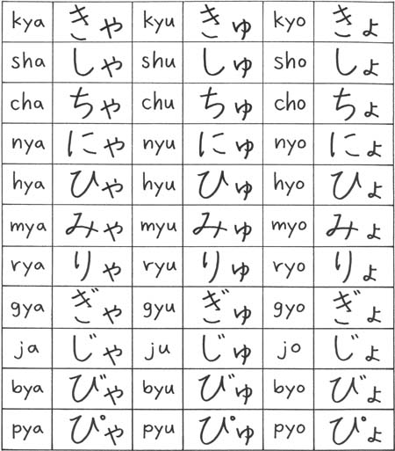
き ＋ ゃ ＝ きゃ

Do you notice anything about the big charcaters? If you look closely, you’ll see the are all from the ‘i’ sound line (ki, shi, ni etc.)
Note that these sounds combine a big character (e.g. ki) and a small character (e.g. ya) to make a new sound (e.g. kya)

Now try yourself:
びゃ |  | じょ |  |  | kya |  | sha |  | ju
きゅ |  | りゅ |  |  | nyu |  | hyo |  | ja
ちょ |  | みゅ |  |  | hyu |  | nyo |  | jo
ぴゃ |  | きょ |  |  | cha |  | chu |  | pya
しょ |  | にゃ |  |  | mya |  | gyu |  | byu
ぎゃ |  | しゅ |  |  | ryo |  | gyo |  | pyu
りゃ |  | ぴょ |  |  | myo |  | hya |  | byo

Hiragana Rules

Try writing the following words using the special hiragana rules we have learned so far including: ten ten and maru, small つ and small や ゆ よ

English | Hiragana | Romaji
Fourteen | じゅうよん
Tomorrow morning | みょうちょう
Baby tooth | にゅうし
A translator | やくしゃ
To withdraw | てっきょう する
Travel | りょこう
Cooking | りょうり
Classroom | きょうしつ
Study | べんきょう
Train | でんしゃ

Hint: Give small size characters their own box – but make sure you still write them small!
English | romaji | Hiragana
Bike | jitensha
Marriage | kekkon
Phone | denwa
Photo | shashin
Exchange student | ryuugakusei
Middle school | chuugakkou
Milk | gyuunyuu
Dictionary | jisho
Doll | ningyou
Sick | byouki
Wind | kaze
Apple | ringo
Child | kodomo

