てんてん・まる　Sound Changes (カタカナ)

てんてん

まる

パ

ギ

By adding てんてん or まる to certain カタカナsymbols, we can make new sounds. The name てんてん comes from the word てん, meaning mark or point, and まる means circle. These symbols are always added to the top right hand corner of theカタカナ, as shown.

Only カタカナ beginning  with  a  **K  (カ),  S  (サ),  T  (タ)**or  **H  (ハ)**sound  can  haveてんてん  added to them, and only characters beginning with a **H (ハ)** sound can have まるadded to them.

Use these phrases and pictures to help remember the sound changes.

**[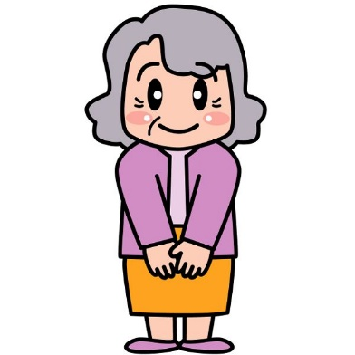](http://www.keirou.net/trivia/illustration.html)**[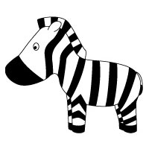](http://www.google.com.au/url?sa=i&rct=j&q=&esrc=s&source=images&cd=&cad=rja&uact=8&docid=9XjlJcPnxtIUaM&tbnid=LBa-Bry5WxZ0vM:&ved=0CAUQjRw&url=http://www.original-21.net/mascot/price.html&ei=xJWwU83JMImIkwWmyIGYDg&bvm=bv.69837884,d.dGI&psig=AFQjCNE4WczBfHNfi06ECOJSIs6AOkJdMQ&ust=1404167997147915)

**K**ind **G**randma

カ　→　ガ (**ga**)

キ　→　ギ (**gi**)

ク　→　グ (**gu**)

ケ　→　ゲ (**ge**)

コ　→　ゴ (**go**)

**S**tripey **Z**ebra

サ　→　ザ(**za**)

シ　→　ジ (**ji**) *

ス　→　ズ (**zu**)

セ　→　ゼ (**ze**)

ソ　→　ゾ (**zo**)

[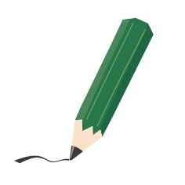](http://www.google.com.au/url?sa=i&rct=j&q=&esrc=s&source=images&cd=&cad=rja&uact=8&docid=MBnsurkzABhkiM&tbnid=gBkPaKNNmY-0sM:&ved=0CAUQjRw&url=http://www.ab-kikaku.jp/funs/illustrations/bungu-index.html&ei=Z5mwU_HpJMmJkQWZyIFA&psig=AFQjCNF0X5DN4x3_CaWP6A8vSpQ7FHtnww&ust=1404168883198925)[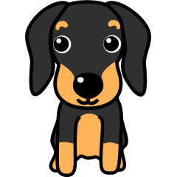](http://www.google.com.au/url?sa=i&rct=j&q=&esrc=s&source=images&cd=&cad=rja&uact=8&docid=d076SXXdwI05VM&tbnid=YdFBodAqjrN_6M:&ved=0CAUQjRw&url=http://www.nigaoe-market.com/dog/download_html/material_02_011.html&ei=JJewU7bJCMukkwW2wYGYBw&bvm=bv.69837884,d.dGI&psig=AFQjCNGtZfKOh4ZK2HhkqCORmhjdDKWA5g&ust=1404168352964991)[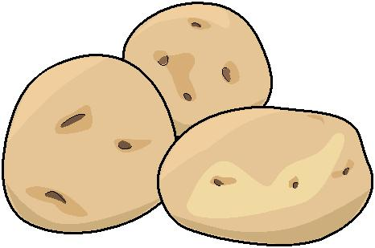](http://www.google.com.au/url?sa=i&rct=j&q=&esrc=s&source=images&cd=&cad=rja&uact=8&docid=w_jv0DxNN0AmJM&tbnid=39JcHZvDV45OgM:&ved=0CAUQjRw&url=http%3A%2F%2Fwww.admcom.co.jp%2Fwanpakuweb%2Fai%2Fsyousai.php%3Ffcode%3D02017&ei=aZawU9rpJcuWkQWck4GIBA&bvm=bv.69837884,d.dGI&psig=AFQjCNE1YP4OTHsgqFflLHkMlMixLpY1MQ&ust=1404168136536464)

**HB** Pencil

ハ　→　バ(**ba**) ヒ　→　ビ (**bi**)　 フ　→　ブ (**bu**)

ヘ　→　ベ (**be**) ホ　→　ボ (**bo**)

カタカナ marked with a * symbol are exceptions to the above rules – シ becomes ‘ji’ instead of ‘zi’, and ヂand ヅ are pronounced similarly to ji and zu, but only used for specific words.

**T**op **D**og

タ　→　ダ(**da**)

チ　→　ヂ (**di**) *

ツ　→　ヅ (**du**) *

テ　→　デ (**de**)

ト　→　ド (**do**)

**H**ot **P**otato

ハ　→　パ(**pa**)

ヒ　→　ピ (**pi**)

フ　→　プ (**pu**)

ヘ　→　ペ (**pe**)

ホ　→　ポ (**po**)