TEN TENS

an00485_[1]

Killer Gorilla K ↔ G か　↔ が

an01244_[1]

T-rex Dinosaur T ↔ D た　↔　だ

[](http://classroomclipart.com/cgi-bin/kids/imageFolio.cgi?action=view&link=Clipart/Holidays&image=birthday_cake11.jpg&img=0&search=birthday%20cake&cat=all&tt=&bool=)

Happy Birthday H ↔ B は　↔　ば

[](http://classroomclipart.com/cgi-bin/kids/imageFolio.cgi?action=view&link=Foods/Food_Clipart&image=pizza.jpg&img=0&search=pizza&cat=all&tt=&bool=)

Hot Pizza H ↔ P は　↔　ぱ　＊

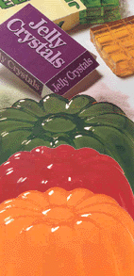

Slippery Jelly S ↔ J し ↔　じ　＊

[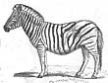](http://classroomclipart.com/cgi-bin/kids/imageFolio.cgi?action=view&link=Animals/Zoology/Zoology2&image=ZS_077zebra.jpg&img=27&search=zebra&cat=all&tt=&bool=)

Striped Zebras S ↔ Z さ ↔　ざ