Time & Verbs Practice

なまえ：

- Listen to the times read out by your teacher and circle the correct one.

3:30 4:00 12:00 7:30

1:00 11:30 2:15 3:45

8:30 6:00 10:20 5:15

10:00 1:30 9:10 11:00

- Practice writing the days of the week in the table below.

Sunday | にちようび
Monday | げつようび
Tuesday | かようび
Wednesday | すいようび
Thursday | もくようび
Friday | きんようび
Saturday | どようび

- Write the correct verb in Japanese underneath each picture.

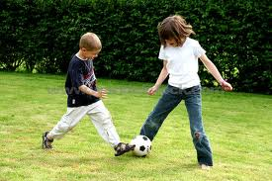

______________ __________ __________

_____________ ___________ ___________

- Translate the following sentences. Use the pattern below to help you.

Day の Time に Object をVerb

- On Sunday at 3 o’clock I will play soccer.
_________________________________________________________

- On Monday I will go to school at 8 o’clock.
_________________________________________________________

- On Friday at 7 o’clock I will go to a party.
_________________________________________________________

- どようび の 十二 じ に えいがかん に いきます。

＿＿＿＿＿＿＿＿＿＿＿＿＿＿＿＿＿＿＿＿＿＿＿＿＿＿＿＿
- すいようび の 四 じはん に ともだち と うみ に いきます。
＿＿＿＿＿＿＿＿＿＿＿＿＿＿＿＿＿＿＿＿＿＿＿＿＿＿＿＿

- Write 3 sentences of your own about your plans for the week ahead. Practice saying them to a partner.

