Travel Grammar Practice

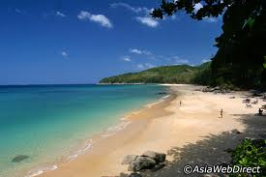
Listen to your teacher read a word in Japanese from the groups below. Circle the correct English word.

a.) beach city party river

b.) park movies shopping beach

c.) mountain hot springs movies park

d.) art gallery mountain museum shopping

e.) museum theme park city hot springs

f.) theme park countryside party art gallery
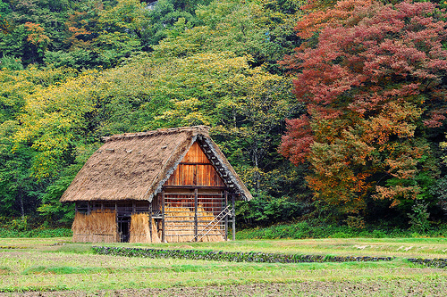

Fill in the missing hiragana for the following words.

River Countryside City

わ
な

ま

Museum Hot springs Park

や
お |  |  | ん
 | う |  | ん

Museum Art gallery
は |  |  | つ

び |  |  |  | か

Match the Japanese word to its English meaning.

じんじゃ theme park

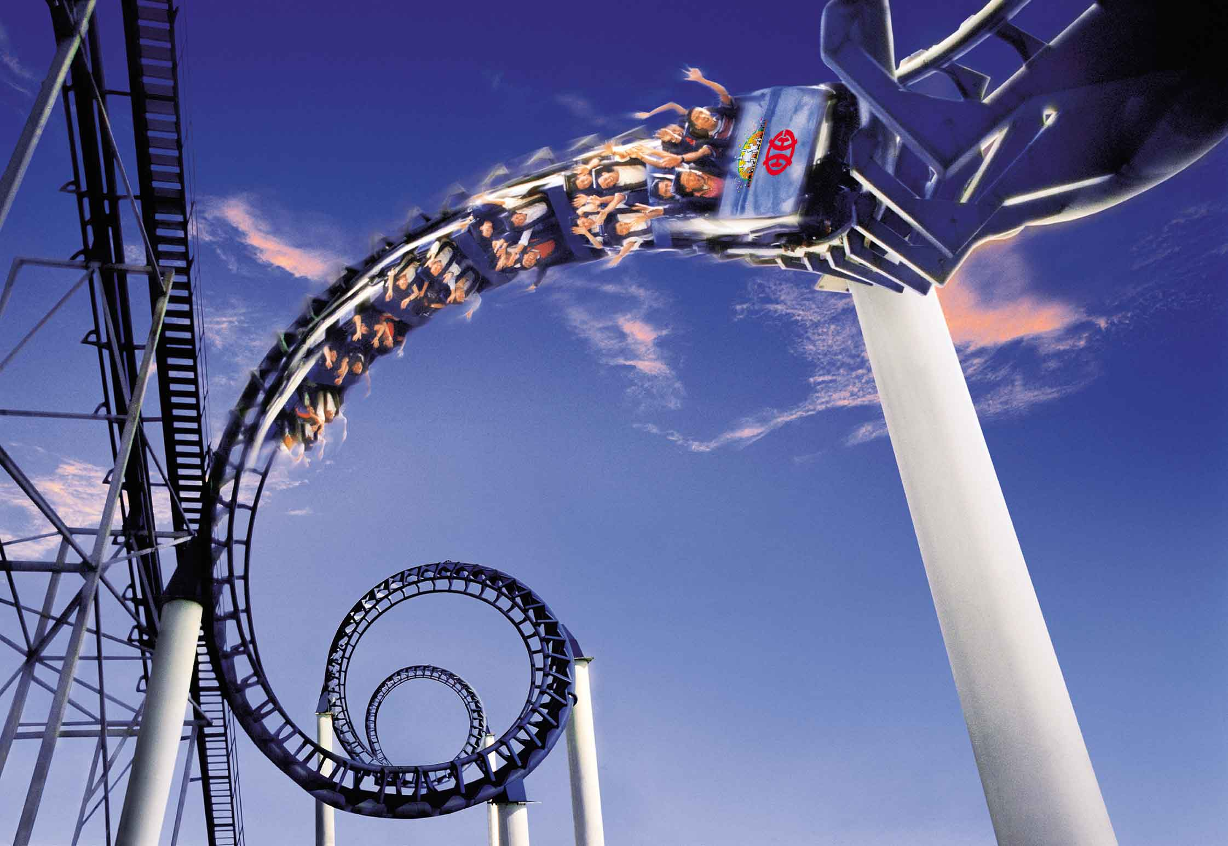
かわ shopping

うみ shrine

かいもの park

ゆうえんち beach

おてら river

こうえん temple

To ask and say where you are going, you will need to use the following pattern:

どこ に いきますか。

Where are you going?

Place に いきます。

I’m going to _________

Use this pattern to translate the following sentences.

- まち に いきます。
＿＿＿＿＿＿＿＿＿＿＿＿＿＿＿＿＿＿＿＿＿＿＿＿＿＿＿＿＿

- おてら に いきます。
＿＿＿＿＿＿＿＿＿＿＿＿＿＿＿＿＿＿＿＿＿＿＿＿＿＿＿＿＿

- Where are you going?
＿＿＿＿＿＿＿＿＿＿＿＿＿＿＿＿＿＿＿＿＿＿＿＿＿＿＿＿＿＿＿＿＿＿

- I am going to the museum。
＿＿＿＿＿＿＿＿＿＿＿＿＿＿＿＿＿＿＿＿＿＿＿＿＿＿＿＿＿＿＿＿＿＿

Who are you going with?

Practice writing the names for the people in Japanese.

Friend | ともだち
Family | かぞく
Mum | はは
Dad | ちち
Teacher | せんせい

- To ask someone who they are going with, you need to use the following pattern:

だれ と いきますか。

Who are you going with?

＿＿＿＿＿と いきます。

I’m going with _________.

Use this pattern to translate the following sentences.

- だれ と いきますか。
＿＿＿＿＿＿＿＿＿＿＿＿＿＿＿＿＿＿＿＿＿＿＿＿＿＿＿＿＿＿＿＿＿＿

- ともだち と いきます。
＿＿＿＿＿＿＿＿＿＿＿＿＿＿＿＿＿＿＿＿＿＿＿＿＿＿＿＿＿＿＿＿＿＿

- はは と かいもの に いきます。
＿＿＿＿＿＿＿＿＿＿＿＿＿＿＿＿＿＿＿＿＿＿＿＿＿＿＿＿＿＿＿＿＿＿

- I’m going to the movies with my friend.
_____________________________________________________________

- I’m going to a football game with dad.

_____________________________________________________________

- I’m going to the art gallery with my teacher.

_____________________________________________________________

How will you get there?

- Write the Japanese word for the following pictures below.

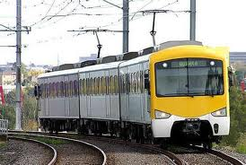
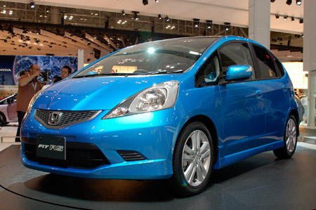
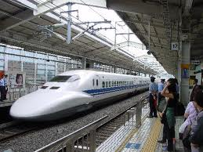

_______________ _______________ _________________
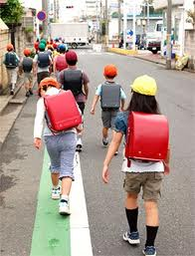
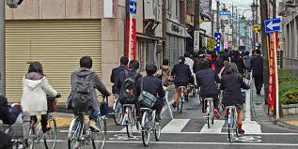
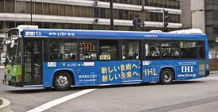

_______________ ________________ ____________________

To ask how someone how they will get somewhere, you will need to use the following pattern.

なん で いきますか。

How will you get there?

＿＿＿＿＿で いきます。

I’m going by _________.

Use this pattern to translate the following sentences:

- なん で いきますか。
＿＿＿＿＿＿＿＿＿＿＿＿＿＿＿＿＿＿＿＿＿＿＿＿＿＿＿＿＿
- でんしゃ で いきます。
＿＿＿＿＿＿＿＿＿＿＿＿＿＿＿＿＿＿＿＿＿＿＿＿＿＿＿＿＿＿＿＿＿＿
- くるま で いきます。
＿＿＿＿＿＿＿＿＿＿＿＿＿＿＿＿＿＿＿＿＿＿＿＿＿＿＿＿＿＿＿＿＿＿
- I go by bus.
＿＿＿＿＿＿＿＿＿＿＿＿＿＿＿＿＿＿＿＿＿＿＿＿＿＿＿＿＿
- I go by train.

___________________________________________________________

