C:\Documents and Settings\dha\Local Settings\Temporary Internet Files\Content.IE5\8J5NSZK5\MCj04238320000[1].wmf

ききます



あいます

C:\Documents and Settings\dha\Local Settings\Temporary Internet Files\Content.IE5\0RLBS5OE\MCj04158020000[1].wmf

のみます

C:\Documents and Settings\dha\Local Settings\Temporary Internet Files\Content.IE5\NB06I4HA\MCj04300490000[1].wmf

よみます



かきます

C:\Documents and Settings\dha\Local Settings\Temporary Internet Files\Content.IE5\ERNJ2J98\MCj04300470000[1].wmf

ねます



とります

C:\Documents and Settings\dha\Local Settings\Temporary Internet Files\Content.IE5\ERNJ2J98\MCj04121800000[1].wmf

ひきます

C:\Documents and Settings\dha\Local Settings\Temporary Internet Files\Content.IE5\ERNJ2J98\MCBD07178_0000[1].wmf

かいます

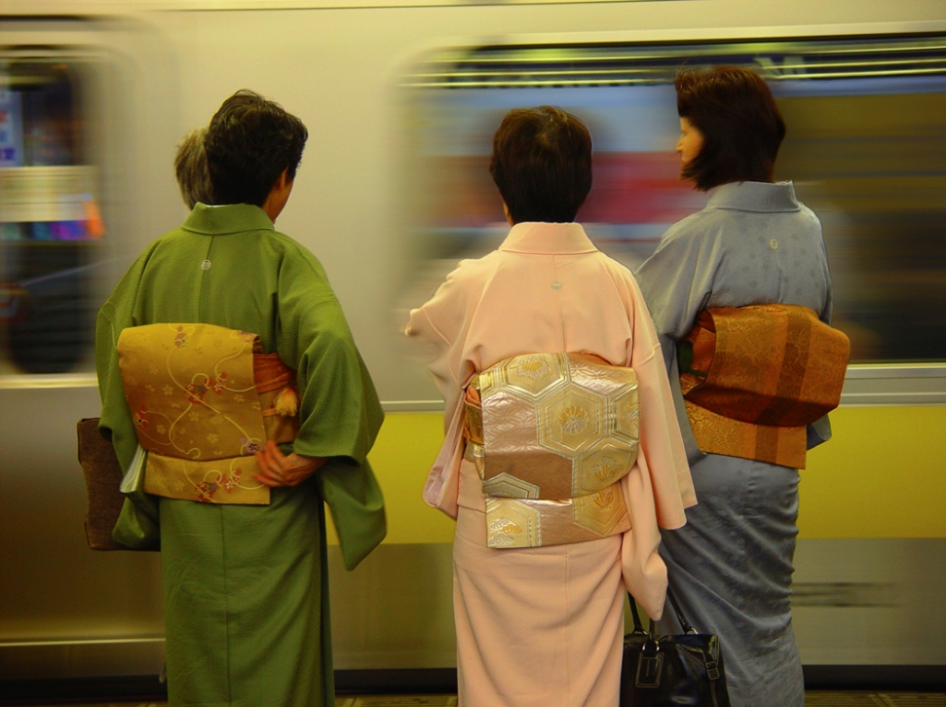C:\Documents and Settings\dha\Local Settings\Temporary Internet Files\Content.IE5\VUKVNKIE\MCj03317020000[1].wmf

のります



たべます

C:\Program Files\Microsoft Office\MEDIA\CAGCAT10\j0285698.wmfC:\Program Files\Microsoft Office\MEDIA\CAGCAT10\j0199036.wmf

します

C:\Documents and Settings\dha\Local Settings\Temporary Internet Files\Content.IE5\KWPMB8L6\MCj02959450000[1].wmf

みます

C:\Documents and Settings\dha\Local Settings\Temporary Internet Files\Content.IE5\VUKVNKIE\MCj04346770000[1].wmf

いきます

C:\Documents and Settings\dha\Local Settings\Temporary Internet Files\Content.IE5\VUKVNKIE\MCBD07213_0000[1].wmf

みせます

C:\Documents and Settings\dha\Local Settings\Temporary Internet Files\Content.IE5\T1NRU1F0\MCj04379880000[1].wmf

**CAN DO**

できます

C:\Documents and Settings\dha\Local Settings\Temporary Internet Files\Content.IE5\I481D0TO\MCj01276030000[1].wmf

もちます



あけます



みせます

C:\Program Files\Microsoft Office\MEDIA\CAGCAT10\j0195384.wmf

つかいます

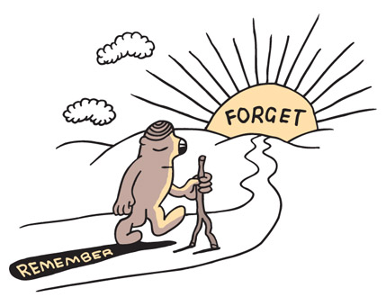

わすれます





きます

しめます

**C:\Documents and Settings\dha\Local Settings\Temporary Internet Files\Content.IE5\W4WUY6L5\MCj03963280000[1].wmf**

あける

C:\Documents and Settings\dha\Local Settings\Temporary Internet Files\Content.IE5\ICUQS3AE\MCj04258180000[1].wmf

HAWTHORN PREMIERS 2009!!

かつ

C:\Documents and Settings\dha\Local Settings\Temporary Internet Files\Content.IE5\W4WUY6L5\MCj03963280000[1].wmf

しめる

C:\Documents and Settings\dha\Local Settings\Temporary Internet Files\Content.IE5\ICUQS3AE\MCj04361290000[1].wmf

おしえる

C:\Documents and Settings\dha\Local Settings\Temporary Internet Files\Content.IE5\URIPXSEZ\MCj04381890000[1].wmf

ひく



とる



ならう



FOUND THEM!!

みつける



さがす

GEELONG

2008 Grand Final

まける

**CAN DO**

C:\Documents and Settings\dha\Local Settings\Temporary Internet Files\Content.IE5\T1NRU1F0\MCj04379880000[1].wmf

できる

C:\Documents and Settings\dha\Local Settings\Temporary Internet Files\Content.IE5\T1NRU1F0\MCj03605160000[1].wmf

はなします