**わたしのかぞく**

|  |  |
| --- | --- |
|  | my family |
|  | my parents |
|  | my father |
|  | my mother |
|  | my brothers and sisters (siblings) |
|  | my older brother |
|  | my older sister |
|  | my younger brother |
|  | my younger sister |

|  |  |
| --- | --- |
|  | my husband |
|  | my wife |
|  | my child |
|  | my son |
|  | my daughter |
|  | my grandfather |
|  | my grandmother |
|  | my grandchild |

1. **Trace the hiragana words below then write the English translation next to them.**

きょうだい そぼ

おとうと かない

あに こども

いもうと まご

はは しゅじん

ちち そふ

かぞく むすこ

りょうしん むすめ

あね

|  |  |
| --- | --- |
|  | one person |
|  | two people |
|  | three people |
|  | four people |
|  | five people |
|  | six people |
| (nana nin) | seven people |
|  | eight people |
| (kyuu nin) | nine people |
|  | ten people |
|  | How many people |

1. **何人　です　か。　Write your answers in Japanese.**

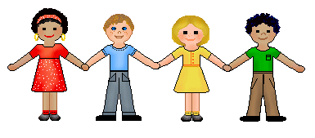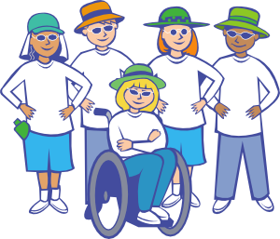

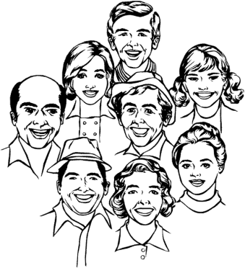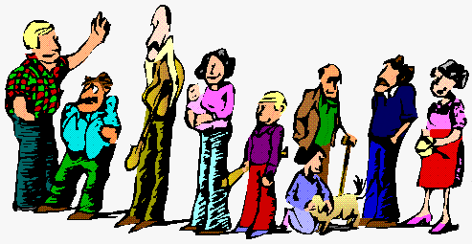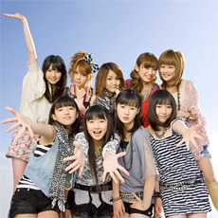

1. **Read the sentences about describing families. Re-write each sentence on the line provided to describe your family.**

**There are 3 people in my family.**

　　。

**_________________________________________________________________________________**

**There are 3 people in my family, my dad, my mum and me.**

、　　　　　　　。

**_________________________________________________________________________________**

**I’m one of three siblings.**

　きょうだい　です。

**_________________________________________________________________________________**

**I have two siblings: one older brother and one younger brother.**

　　　。　　　　　　　。

**_________________________________________________________________________________**

**I have two older brothers and a younger sister.**

　　　　　　　　　。

**_________________________________________________________________________________**

1. 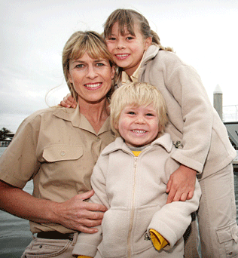**Read about these families. Find one mistake in each family description.**

わたし　は　**・**です。　かぞく　は　はは　と　おとうと　と　わたし　の　二人　です。

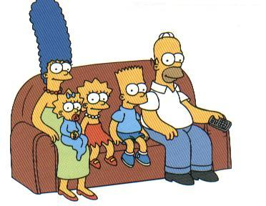

ぼく 　は　**・**です。　五人　かぞく　です。　きょうだい　は　二人　です。　あね　が　二人　います。

わたし 　は　**・**です。

五人　かぞく　です。　しゅじん　と　むすめ　が　三人　います。

しゅじん　は　せんしゅ　です。

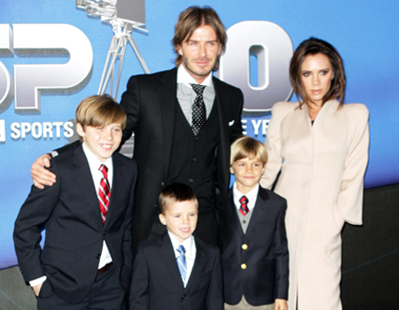

1. Draw a picture of your family in the box below. Then, write about your family in Japanese. (Use the reading passages in 4 to help you.)

________________________________________________________________________________________

________________________________________________________________________________________

________________________________________________________________________________________

________________________________________________________________________________________

________________________________________________________________________________________

________________________________________________________________________________________

________________________________________________________________________________________

________________________________________________________________________________________

________________________________________________________________________________________

________________________________________________________________________________________

________________________________________________________________________________________