てんき
なまえ：＿＿＿＿＿＿＿
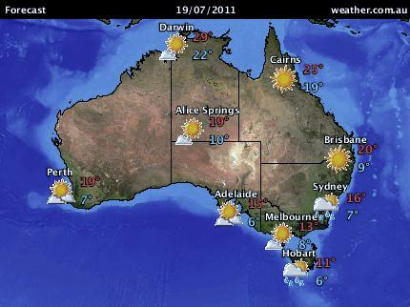
Write about the weather for each city.
Eg. Adelaide ______アデレードは はれ です。 15ど です。_
Alice Springs_________________________________________________
Brisbane____________________________________________________
Cairns______________________________________________________
Darwin______________________________________________________
Hobart______________________________________________________
Melbourne___________________________________________________
Perth________________________________________________________
Sydney______________________________________________________

