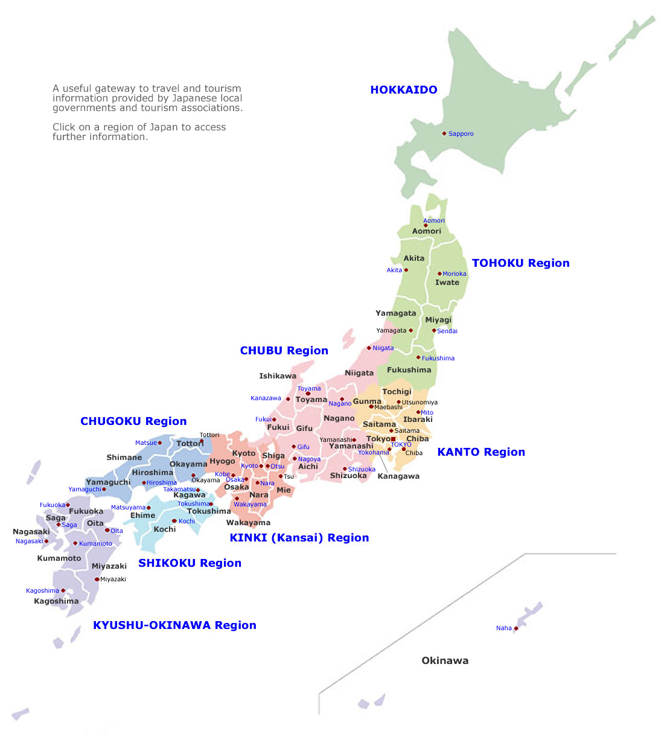
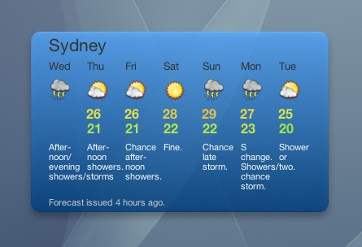

- Listen for and label the map with appropriate weather
- Answer these questions in Japanese using the forecast for Sydney at the top of the page

- 木曜日 の 天気 は どう でしたか？
Mokuyoubi no tenki wa dou deshitaka
______________________________________
- 土曜日の天気はどうですか？
______________________________________
- What is the top temperature for Monday?
___________________________________

- Complete the table below based on the information provided

月 |  |  | 木 | 金
 | 晴れ |  | 曇り時々雨 | 雨
 |  |  | Kumori toki doki ame

- EXTENSION :
Create a weather map based on the information provided.

天気
Perth に 暖かいです。晴れです。
Darwin に 暖かいです。晴れです。
Brisbaneに 涼しいです。 曇り時々雨です。
Canberraに 寒いです。曇り時々雪です。
Melbourneに 寒いです。曇りです。

What time of year do you think this forecast would be heard?



