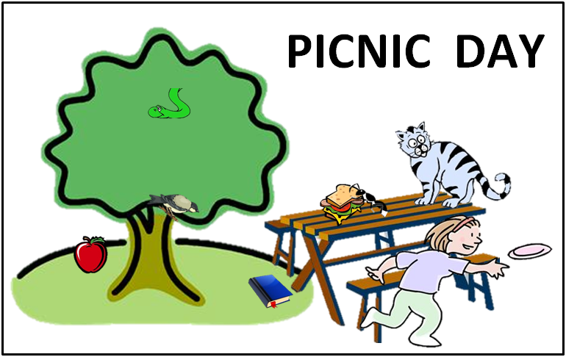

**WRITING TASK:** Please write a sentence in the spaces provided below about each object according to their location in the above picture. Keep in mind the difference between animate and inanimate objects.

|  |  |
| --- | --- |
| apples,food,fruits,nature,plants |  |
| animals,cartoons,reptiles,smiling,snakes |  |
| campgrounds,households,leisure,outdoor furniture,picnic tables,tables |  |
| animals,bugs,carpenter ants,creatures,insects,nature,wildlife |  |
| animals,cats,creatures,mammals,nature,petsアメリカコガラ,さえずり,動物,止まり木,鳥 |  |
|  |  |
| back to school,books,cropped images,cropped pictures,diaries,education,PNG,readings,transparent backgrounds |  |
| frisbees,girls,household,leisure,people,tossing,toys,playing |  |
| nature,plants,trees,hills,grass,greens,travel |  |
| cheeses,dining,food,lettuces,lunches,meats,sandwiches,tomatoes,breads,slices,vegetables |  |

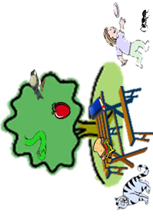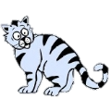apples,food,fruits,nature,plants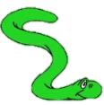animals,bugs,carpenter ants,creatures,insects,nature,wildlife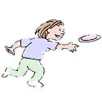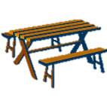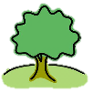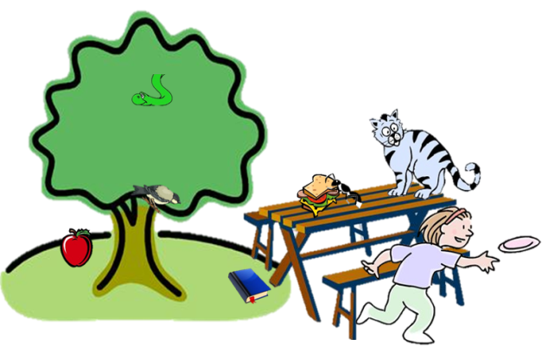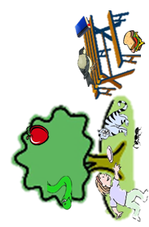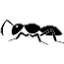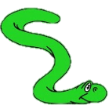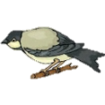

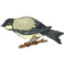

FIND YOUR PARTNER