Writing an Invitation

Let’s research about Japanese events!
日本のイベントについてしらべましょう！

Task: Your task is to research an event or festival in Japan and to make an invitation for your classmates to this event. You need to use Keynote to present your information and invitation.

Guidelines to help you:
- Include a title page
- In the first few slides describe the festival/event.
- What is it?
- Where and when is it held?
- What’s the history behind it?
- Who participates?
- Is there any specific activity done at this festival/event?
- Is there any specific food and drink associated with it?
- Include pictures
This section should be written in English, however make sure to include specific vocabulary related to the event in Japanese.
- Explain why you chose this festival/event. To be done in English.
- Create an invitation in Japanese for your classmates on one slide. Include:
- An invitational phrase
- A short description of the festival/event and what you will do
- Date of the festival/event
- Specific time of festival/event OR time to meet
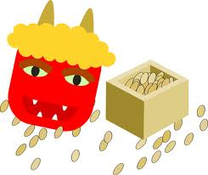
- City the event takes place in
- Where to meet
- Transport used to get there
- What to bring
- When to respond by and your contact details

KEY PHRASES:
- ~ませんかWon’t you…?
- ひづけ: date
- のりもの: transport
- もってくるもの: Things to bring
- へんじ: reply
- 〜まで: by
- ~ましょうLet’s…
- きてくださいPlease come!
- ばしょ: place
- じかん: time
- どこ: where
- いつ: when

