Food and Drink Writing Practice
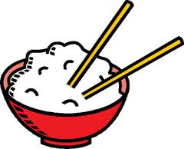
Write the correct hiragana, kanji or katakana in the boxes for the English words
- Eat
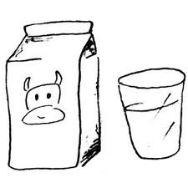
- Drink
- Rice
- Milk
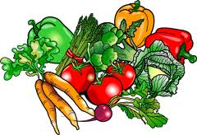
- Fruit
- Vegetables
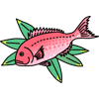
- Slices of Raw Fish
- Meat
- Fish
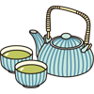
- Salad
- Chicken
- Eggs
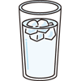
- Dinner
- Breakfast
- Green Tea
- Water

