はち



Name: Class:

なまえ： 　くらす：

### 

お は よ う お は よ う

o - ha - yo - u o - ha - yo - u

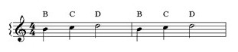

***VERSE TWO:***

*Arigatou Arigatou*

*Gomen nasai Gomen nasai*

*Sumimasen Sumimasen*

*Daijou bu Daijou bu*

***VERSE THREE:***

*Hajimemashite Hajimemashite*

*Dozo yoroshiku Dozo yoroshiku*

*Ogenki desu ka Ogenki desu ka*

*Genki desu yo Genki desu yo*

こ ん に ち は こ ん に ち は

kon - nichi – wa kon - nichi - wa

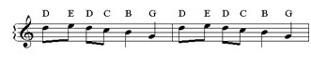

さ よ な ら さ よ な ら

sa - yo - na – ra sa - yo - na – ra

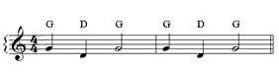

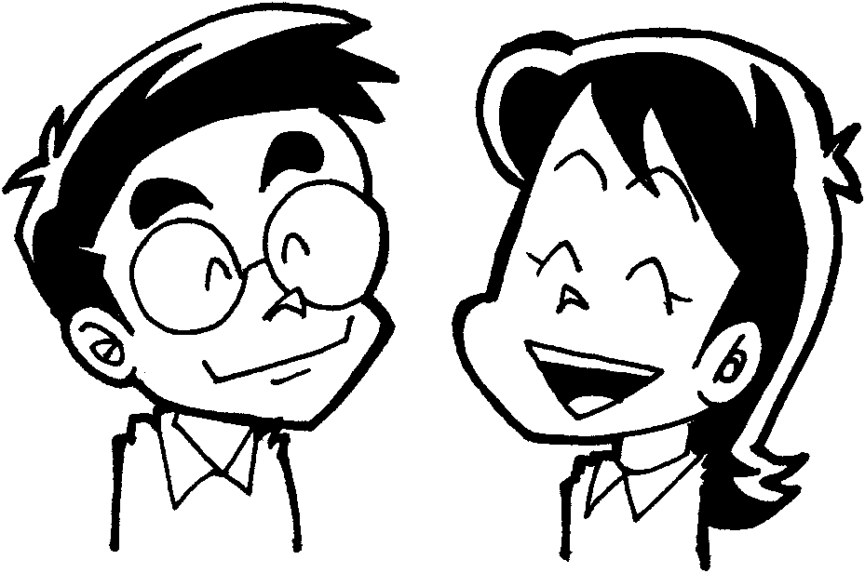

ま た ら い しゅ う ま た ら い し ゅ う

mata – rai – shuu mata – rai – shuu

From http:// [www.japteach.com](http://www.japteach.com)

**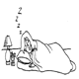**

ume-10ume-10**Greetings Find-a-Word**

**Write the Japanese in the practice boxes for the following English words. Then find and circle the Japanese words in the find-a-word.**

**1. Yes 2. No**

|  |  |
| --- | --- |
|  |  |

|  |  |  |
| --- | --- | --- |
|  |  |  |

**4. I am sorry**

|  |  |  |  |  |
| --- | --- | --- | --- | --- |
|  |  |  |  |  |

|  |  |  |  |  |  |
| --- | --- | --- | --- | --- | --- |
|  |  |  |  |  |  |

**3. Thank you**

**5. Excuse me 6. Good Morning**

|  |  |  |  |  |
| --- | --- | --- | --- | --- |
|  |  |  |  |  |

|  |  |  |  |
| --- | --- | --- | --- |
|  |  |  |  |

**ume-10ume-10 7. Good Afternoon 8. Good Evening**

|  |  |  |  |  |
| --- | --- | --- | --- | --- |
|  |  |  |  |  |

|  |  |  |  |  |
| --- | --- | --- | --- | --- |
|  |  |  |  |  |

**9. Good Night 10. Good bye**

|  |  |  |  |
| --- | --- | --- | --- |
|  |  |  |  |

|  |  |  |  |  |
| --- | --- | --- | --- | --- |
|  |  |  |  |  |

|  |  |  |  |  |  |  |  |  |
| --- | --- | --- | --- | --- | --- | --- | --- | --- |
| **よ** | **い** | **こ** | **ん** | **ば** | **ん** | **は** | **が** | **あ** |
| **ご** | **め** | **ん** | **な** | **さ** | **い** | **と** | **り** | **い** |
| **す** | **ん** | **に** | **ら** | **さ** | **お** | **が** | **い** | **た** |
| **み** | **は** | **ち** | **う** | **よ** | **と** | **や** | **え** | **だ** |
| **ま** | **お** | **は** | **よ** | **う** | **な** | **さ** | **す** | **い** |
| **gohomeせ** | **あ** | **り** | **が** | **な** | **ま** | **し** | **い** | **getupgreetみ** |
| **ん** | **す** | **か** | **は** | **ら** | **す** | **え** | **ら** | **な** |

**ume-10ume-10**

**Match the following greetings to the English expressions.**

さようなら Hello

おはようございます See you later

おはよう Good evening

じゃまたね Good morning

こんばんは Good night

おやすみなさい Good bye

こんにちは `Mornin’

ume-10ume-10

**Fill in the missing hiragana letters in the following greetings.**

**お＿よ＿**

**こ＿＿んは**

**さよ＿な＿**

**お＿すみ＿＿い**

**＿ま＿ね**

**おは＿うご＿い＿す**

**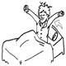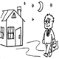**

What’s your name?

How to say your own name:

わたし　は　（ｙｏｕｒ　ｎａｍｅ）　です。

I am (your name).

Asking someone their name:

The most grammatically correct way to ask someone’s name is:

おなまえ　は　なん　ですか。(What is your name?)

The most natural way to ask someone’s name:

おなまえ　は？ (You are?)

**Task:** Ask as many people as you can in 2 minutes, おなまえ　は？

|  |  |  |  |
| --- | --- | --- | --- |
| Name | Secret Identity | Name | Secret Identity |
|  |  |  |  |
|  |  |  |  |
|  |  |  |  |
|  |  |  |  |
|  |  |  |  |

Introducing yourself

*Read the first two speech bubbles.*

*Complete the blanks so that the people are introducing themselves*

　　　はじめまして。

ぼく　の　なまえ　は　じょん　です。

こんにちは。

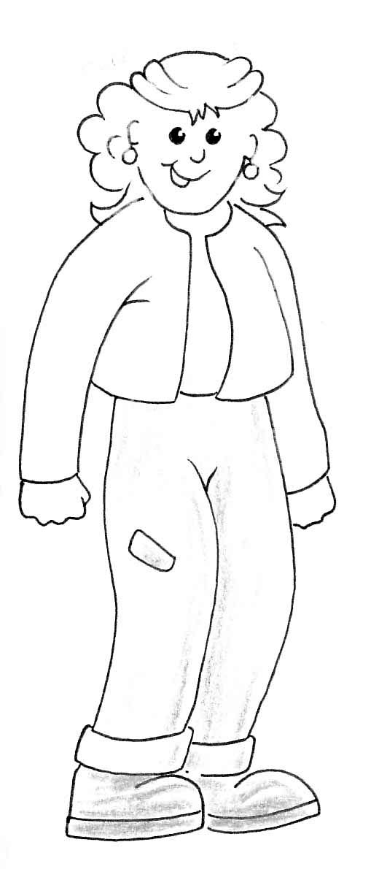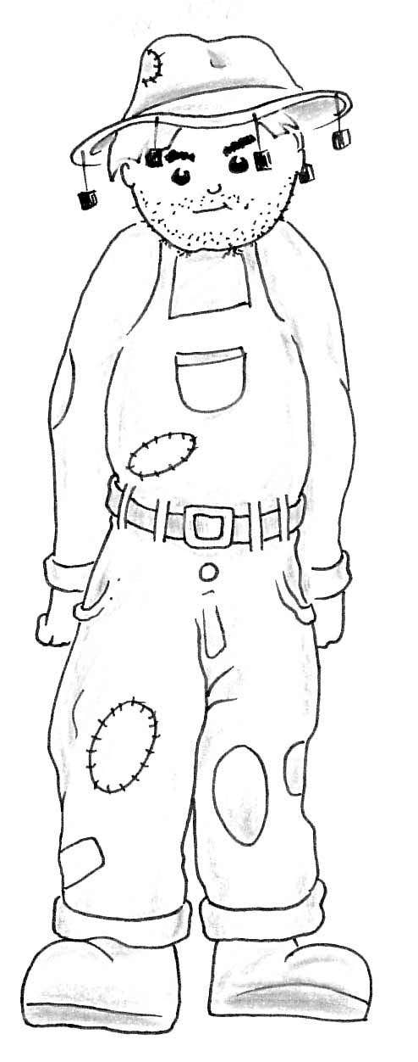

はじめまして。

わたし　は　さまんさ です。

こんにちは。

\_\_\_\_\_\_\_\_\_\_\_\_\_\_\_\_

\_\_\_\_\_\_\_　\_\_　\_\_\_\_\_\_\_\_　\_\_　あけぼの　\_\_\_\_\_

\_\_\_\_\_\_\_\_\_\_\_\_\_\_\_\_

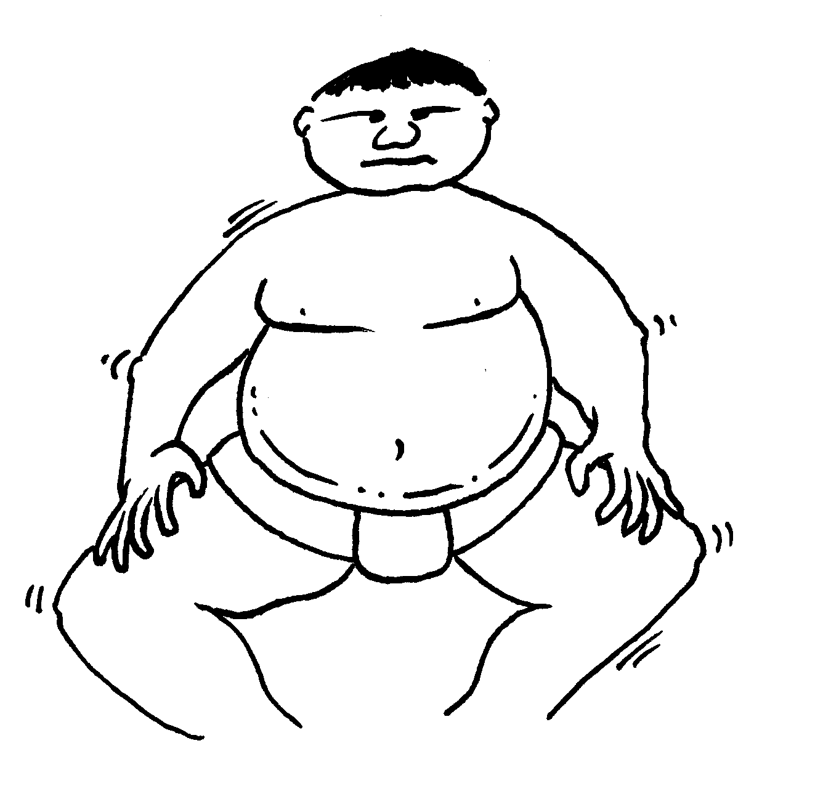

*(Tom)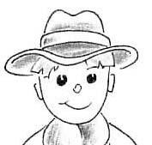*

\_\_\_\_\_\_\_\_\_\_\_\_\_\_\_\_\_\_\_\_\_\_\_\_

\_\_\_\_\_\_\_\_\_\_\_\_\_\_\_\_\_\_\_\_\_\_\_\_\_\_\_\_\_\_\_\_\_\_\_\_\_\_\_\_\_\_\_

\_\_\_\_\_\_\_\_\_\_\_\_\_\_\_\_\_\_\_\_\_\_\_\_

# Draw a picture of yourself, and write an introduction

From http://www.languageteachers.net/

Numbers 1-10

|  |  |
| --- | --- |
| C:\WINDOWS\Application Data\Microsoft\Media Catalog\Downloaded Clips\cl0\SY01847_.wmfItchyhttp://www-mddsp.enel.ucalgary.ca/People/dreveny/itchy/itchy.gifC:\WINDOWS\Application Data\Microsoft\Media Catalog\Downloaded Clips\cl0\SY01852_.wmfC:\WINDOWS\Application Data\Microsoft\Media Catalog\Downloaded Clips\cl71\j0283458.gif  Lock  ろく  Itchy  いち  ctchy |  |
| C:\WINDOWS\Application Data\Microsoft\Media Catalog\Downloaded Clips\cl36\j0137243.wmfC:\WINDOWS\Application Data\Microsoft\Media Catalog\Downloaded Clips\cl0\HM00385_.wmfC:\WINDOWS\Application Data\Microsoft\Media Catalog\Downloaded Clips\cl0\SY01848_.wmfC:\WINDOWS\Application Data\Microsoft\Media Catalog\Downloaded Clips\cl0\SY01853_.wmf  nana  なな  Knee  に |  |
| http://mbs.valinet.com/~jds/hatch.gifhttp://users.skynet.be/bd/images/xs1/sun14.gifC:\WINDOWS\Application Data\Microsoft\Media Catalog\Downloaded Clips\cl0\SY01849_.wmfC:\WINDOWS\Application Data\Microsoft\Media Catalog\Downloaded Clips\cl0\SY01854_.wmf  hatch  はち  Sun  さん |  |
| <http://www.venables.co.uk/gifs/queue.gif>C:\WINDOWS\Application Data\Microsoft\Media Catalog\Downloaded Clips\cl0\AG00290_.gifC:\WINDOWS\Application Data\Microsoft\Media Catalog\Downloaded Clips\cl0\SY01850_.wmfC:\WINDOWS\Application Data\Microsoft\Media Catalog\Downloaded Clips\cl0\SY01855_.wmf  queue  きゅう  She  し |  |
| C:\WINDOWS\Application Data\Microsoft\Media Catalog\Downloaded Clips\cl30\j0120865.wmfC:\WINDOWS\Application Data\Microsoft\Media Catalog\Downloaded Clips\cl0\AG00276_.gifC:\WINDOWS\Application Data\Microsoft\Media Catalog\Downloaded Clips\cl0\SY01896_.wmfC:\WINDOWS\Application Data\Microsoft\Media Catalog\Downloaded Clips\cl0\SY01851_.wmfC:\WINDOWS\Application Data\Microsoft\Media Catalog\Downloaded Clips\cl0\SY01846_.wmfC:\WINDOWS\Application Data\Microsoft\Media Catalog\Downloaded Clips\cl0\SY01847_.wmf  Ju (-do)  じゅう  go  ご |  |

2

1

1

1

1

|  |  |  |  |  |  |  |  |  |  |
| --- | --- | --- | --- | --- | --- | --- | --- | --- | --- |
| 一  1 | 二  2 | 三  1  3  2 | 四  5  4  3  2 | 五  4  3  1  2 | 六  4  3  2 | 七  2  1 | 八  2  1 | 九  2 | 十  1 |
| 一 | 二 | 三 | 四 | 五 | 六 | 七 | 八 | 九 | 十 |
| 一 | 二 | 三 | 四 | 五 | 六 | 七 | 八 | 九 | 十 |
| 一 | 二 | 三 | 四 | 五 | 六 | 七 | 八 | 九 | 十 |
| 一 | 二 | 三 | 四 | 五 | 六 | 七 | 八 | 九 | 十 |
|  |  |  |  |  |  |  |  |  |  |
|  |  |  |  |  |  |  |  |  |  |
|  |  |  |  |  |  |  |  |  |  |
|  |  |  |  |  |  |  |  |  |  |
|  |  |  |  |  |  |  |  |  |  |
|  |  |  |  |  |  |  |  |  |  |
|  |  |  |  |  |  |  |  |  |  |



Asking telephone numbers:

でんわ　ばんごう　は　なん　ですか。

What’s your telephone number?

(four numbers) の(four numbers) 　です。

It’s (give the numbers in your telephone number).

**Task:** You have 2 minutes to ask as many people as you can their telephone number.

|  |  |
| --- | --- |
| なまえ | でんわ　ばんごう |
|  |  |
|  |  |
|  |  |
|  |  |
|  |  |
|  |  |
|  |  |
|  |  |
|  |  |
|  |  |
|  |  |
|  |  |
|  |  |
|  |  |
|  |  |

**Task:** Write the following telephone numbers in kanji:

の

Your number:

の

Saint Mary’s College:

の

A Friend’s telephone number:

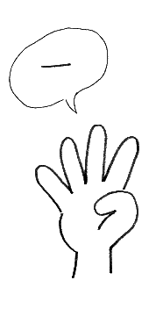Lyrics: Nan sai desu ka

*Movement: Clap clap clap clap*

** Nan sai desu ka**

*Clap clap clap clap*

**Nan sai desu ka**

*Clap clap clap clap*

**Juu sai desu**

*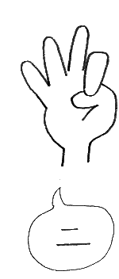 Show 10 fingers*

**Juu is-sai desu**

*Show 11fingers*

**Juu ni-sai desu**

*Show 12fingers*

**Juu san-sai desu**

*Show 13fingers*

*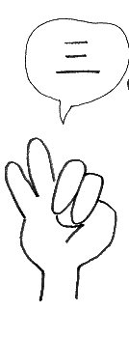*  **Juu yon-sai desu**

*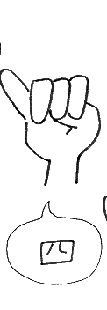 Show 14fingers*

**Juu go-sai desu**

*Show 15fingers*

**Juu roku-sai desu**

*Show 16fingers*

**Juu is-sai, Juu ni-sai, Juu san-sai**

*Jump Jump Jump*

**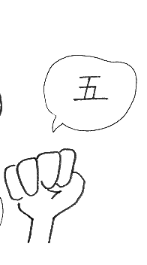 Juu yon-sai, Juu go-sai, Juu roku-sai**

*Jump Jump Jump*

To the GenkiNet Japan numbers 1-20 You Tube rap.



From http:// [www.japteach.com](http://www.japteach.com)

**j0232291とし**

From http:// [www.japteach.com](http://www.japteach.com)

**toshi**

**How old are you?**

**Q. 何 才 です か**

**nan sai desu ka**

**I am ….. years old**

**A. number 才　です。**

**sai desu.**

**Use the chart to find out how old you are. Practise saying the ages aloud.**

|  |  |  |
| --- | --- | --- |
| **えいご** | **日本語** | **Kanji かんじ** |
| 1 year old | *issai* | 一才 |
| 2 years old | *nisai* | 二才 |
| 3 years old | *sansai* | 三才 |
| 4 years old | *yonsai* | 四才 |
| 5 years old | *gosai* | 五才 |
| 6 years old | *rokusai* | 六才 |
| 7 years old | *nanasai* | 七才 |
| 8 years old | *hassai* | 八才 |
| 9 years old | *kyusai* | 九才 |
| 10 years old | *jussai* | 十才 |
| 11 years old | *juuissai* | 十一才 |
| 12 years old | *juunisai* | 十二才 |
| 13 years old | *juusansai* | 十三才 |
| 14 years old | *juuyonsai* | 上四才 |

**Handy Hint: Remember when you are talking about age to always use *‘yon’* for number four and *‘nana’* for number seven. Also, can you see how number 1, 8 and 11 are a little different to *‘ichi,hachi and juichi’*? This is because these numbers change when we are talking about age. *Ichi* becomes *iss* and *hachi* becomes *hass*!**

**あんけーと**

**Task:** You have 2 minutes to ask as many people in class how old they are. Don’t forget to ask:

|  |  |
| --- | --- |
| **なんさい　です　か。** | |
| **なまえ** | **とし** |
|  |  |
|  |  |
|  |  |
|  |  |
|  |  |
|  |  |
|  |  |
|  |  |
|  |  |
|  |  |
|  |  |
|  |  |
|  |  |
|  |  |
|  |  |
|  |  |
|  |  |
|  |  |

**Task:** Answer the following questions in your Japanese workbooks.

1. まどんな　さん　は　なんさい　です　か。
2. れいでぃー・がーが　さん　は　なんさい　です　か。
3. ろばーと・ぱてぃんそん　さん　は　なんさい　です　か。
4. みーがん・ふぉくす　さん　は　さんさい　です　か。
5. じゃすてぃん・ばいべー　さん　は　さんさい　です　か。

**How do you say the following in Japanese?**

What grade are you in? \_\_\_\_\_\_\_\_\_\_\_\_\_\_\_\_\_\_\_\_\_\_\_\_\_\_\_\_\_\_\_\_\_\_\_\_\_\_\_\_\_\_\_\_\_\_\_\_\_

I’m in grade 8. \_\_\_\_\_\_\_\_\_\_\_\_\_\_\_\_\_\_\_\_\_\_\_\_\_\_\_\_\_\_\_\_\_\_\_\_\_\_\_\_\_\_\_\_\_\_\_\_\_\_\_\_

Explanation: To say what grade you are in use the following pattern.

School grade + ねんせい　です。 = I’m in grade …..

‘ねん’ means year. ‘せい’ means student (as in the word ‘せいと’). Together, these two words mean “a student of Year …..”.

**Task 1:** Read the speech bubbles and translate them into English on the right hand side.

こんにちは。わたしは　ばーと

です。八才です。三ねんせい　です。

 \_\_\_\_\_\_\_\_\_\_\_\_\_\_\_\_\_\_\_\_\_\_\_\_\_\_\_\_\_\_

\_\_\_\_\_\_\_\_\_\_\_\_\_\_\_\_\_\_\_\_\_\_\_\_\_\_\_\_\_\_

\_\_\_\_\_\_\_\_\_\_\_\_\_\_\_\_\_\_\_\_\_\_\_\_\_\_\_\_\_\_

おはよう　ございます。わたしは　りーさ　です。　七才　です。二ねんせい　です。

\_\_\_\_\_\_\_\_\_\_\_\_\_\_\_\_\_\_\_\_\_\_\_\_\_\_\_\_\_\_

 \_\_\_\_\_\_\_\_\_\_\_\_\_\_\_\_\_\_\_\_\_\_\_\_\_\_\_\_\_\_

\_\_\_\_\_\_\_\_\_\_\_\_\_\_\_\_\_\_\_\_\_\_\_\_\_\_\_\_\_\_

\_\_\_\_\_\_\_\_\_\_\_\_\_\_\_\_\_\_\_\_\_\_\_\_\_\_\_\_\_\_\_

はじめまして。わたしは　るーし　です。十三才　です。八ねんせい　です。

PE00686_ \_\_\_\_\_\_\_\_\_\_\_\_\_\_\_\_\_\_\_\_\_\_\_\_\_\_\_\_\_\_\_\_

\_\_\_\_\_\_\_\_\_\_\_\_\_\_\_\_\_\_\_\_\_\_\_\_\_\_\_\_\_\_\_\_

**Task 2:** In your Japanese books draw a picture of yourself. In a speech bubble introduce yourself in Japanese. Include a greeting, your name, age and grade.

From http://www.languageteachers.net/

c:\Program Files\Microsoft Office 2000\Clipart\corpbas\j0079252.wmfc:\Program Files\Microsoft Office 2000\Clipart\corpbas\j0079252.wmf

c:\Program Files\Microsoft Office 2000\Clipart\standard\stddir4\pe02550_.wmf

c:\Program Files\Microsoft Office 2000\Clipart\standard\stddir4\pe02045_.wmfc:\Program Files\Microsoft Office 2000\Clipart\corpbas\j0079252.wmfc:\Program Files\Microsoft Office 2000\Clipart\corpbas\j0079252.wmfCOOKING りょうり(RYOORI)

c:\Program Files\Microsoft Office 2000\Clipart\standard\stddir4\pe02760_.wmfREADING どくしょ(DOKUSHO)

c:\Program Files\Microsoft Office 2000\Clipart\smbusbas\pe07279_.wmfSTAMP COLLECTING きってしゅうしゅう (KITTESHUSHU)

c:\Program Files\Microsoft Office 2000\Clipart\Pub60Cor\pe00998_.wmf

SHOPPING かいもの (KAIMONO)

SPORT すぽーつ(SUPOOTSU)

DRAWING え (E)

c:\Program Files\Microsoft Office 2000\Clipart\smbusbas\pe07429_.wmf

DANCING だんす (DANSU)

c:\Program Files\Microsoft Office 2000\Clipart\standard\stddir1\bd06808_.wmfCOMPUTERS ぱそこん (PASAKON)

c:\Program Files\Microsoft Office 2000\Clipart\standard\stddir2\en00508_.wmfじょうば (JYOOBA) HORSE RIDING

c:\Program Files\Microsoft Office 2000\Clipart\standard\stddir4\pe01954_.wmf

はいきんぐ (HAIKINGU) HIKING

c:\Program Files\Microsoft Office 2000\Clipart\Pub60Cor\pe02282_.wmfおんがく　を　きくこと (ONGAKU WO KIKUKOTO) LISTENING TO MUSIC

ぴあの (PIANO) PIANO

c:\Program Files\Microsoft Office 2000\Clipart\corpbas\j0079254.wmf

すいえい (SUIEI) SWIMMING

c:\Program Files\Microsoft Office 2000\Clipart\corpbas\j0079252.wmfc:\Program Files\Microsoft Office 2000\Clipart\corpbas\j0079252.wmf

**c:\Program Files\Microsoft Office 2000\Clipart\corpbas\j0079252.wmfc:\Program Files\Microsoft Office 2000\Clipart\corpbas\j0079252.wmfWhen talking and asking questions about hobbies use the following sentence patterns.**

# Talking about your hobby/hobbies

c:\Program Files\Microsoft Office 2000\Clipart\standard\stddir4\pe03183_.wmfわたし の しゅみ は ＿＿＿ です。

Watashi no shumi wa\_\_\_\_\_desu

Example:

わたし の しゅみ は だんす です。

Watashi no shumi wa dansu desu.

My hobby is reading.

**LISTING MORE THAN ONE HOBBY!!**

Particle と(to) is used to list more than one thing. と=and

C:\Program Files\Microsoft Office 97\Clipart\Scrbeans\BBQ.WMFc:\Program Files\Microsoft Office 2000\Clipart\standard\stddir1\bd05615_.wmfExample:

わたし の しゅみ は かいもの と りょうり です。

Watashi no shumi wa kaimono to ryoori desu.

My hobbies are shopping and cooking.

# **Asking about hobbies**

しゅみはなんですか。

Shumi wa nan desuka

What is your hobby?

**To answer, you can either say:**

しゅみは＿＿＿です。

Shumi wa \_\_\_\_\_\_desu.

Or

(hobby)です。

c:\Program Files\Microsoft Office 2000\Clipart\corpbas\j0079252.wmfc:\Program Files\Microsoft Office 2000\Clipart\corpbas\j0079252.wmfc:\Program Files\Microsoft Office 2000\Clipart\corpbas\j0079252.wmf

**c:\Program Files\Microsoft Office 2000\Clipart\corpbas\j0079252.wmfc:\Program Files\Microsoft Office 2000\Clipart\corpbas\j0079252.wmfInterview 5 people in the class and find out what their hobby is.**

Ask: しゅみ は なん ですか

Shumi wa nan desuka

Reply: (hobby) です。

desu

|  |  |  |
| --- | --- | --- |
|  | **なまえ** | **しゅみ** |
| 一 |  |  |
| 二 |  |  |
| 三 |  |  |
| 四 |  |  |
| 五 |  |  |

Each person reports back to the class about someone they have interviewed.

\_\_\_\_\_\_\_\_\_\_さん の しゅみ は\_\_\_\_\_\_\_\_\_\_\_\_です。

san no shumi wa desu

Example:

Mary さん の しゅみ は りょうり です。 Mary’s hobby is cooking.

san no shumi wa ryoori desu.

c:\Program Files\Microsoft Office 2000\Clipart\corpbas\j0079252.wmfc:\Program Files\Microsoft Office 2000\Clipart\corpbas\j0079252.wmfc:\Program Files\Microsoft Office 2000\Clipart\corpbas\j0079252.wmf

***Saying Likes and Dislikes***

***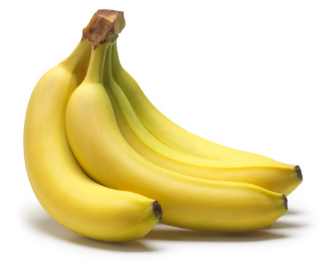I Really like / I love:***

* (Thing you like) が　だい　すき　です。
* ( Thing you like) ga　dai suki　desu.
* Eg: Banana が　だい　すき　です。

　　　　　Banana ga 　dai suki desu

**I like:**

* 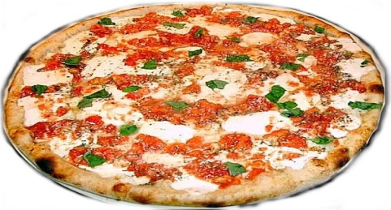(Thing you like) が　すき　です。
* ( Thing you like) Ga　Suki　Desu.
* Eg: ぴざ が　すき　です。

piza ga suki desu.

**I Don’t like:**

* 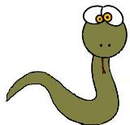(Thing you dislike) は　すき　じゃ　ない　です。
* ( Thing you dislike) wa suki ja nai desu.
* Eg: へび は　すき　じゃ　ない　です。

　　　hebi wa suki ja nai desu.



**I Don’t like:**

* (Thing you dislike) は　きらい　です。
* ( Thing you dislike) wa kirai desu.
* Eg: がっこう は　きらい　です。

　　　gakkoo wa suki ja nai desu.

たんご　Ｖｏｃａｂｕｌａｒｙ

# Greetings and farewells

|  |  |  |
| --- | --- | --- |
| にほんご | Romaji | English |
|  | ohayoo | greeting in the morning |
|  | ohayoo gozaimasu | greeting in the morning (polite) |
|  | konnichiwa | greeting in the afternoon |
|  | konbanwa | greeting in the evening |
|  | oyasumi nasai | good night (said when you go to bed) |
|  | sayoonara | good bye |
|  | ja, mata | see you (later) |
| ばいばい | bai bai | bye |

# Meeting people for the first time

|  |  |  |
| --- | --- | --- |
| にほんご | Romaji | English |
|  | hajimemashite | how do you do? |
|  | doozo yoroshiku | nice to meet you |
|  | watashi | me (for girls) |
|  | boku | me (for boys) |
|  | no | ‘s (possession marker) |
|  | namae | name |
|  | wa | topic marker (written as hiragana letter ha) |
|  | desu | is |
|  | nan | what |
|  | ka | voiced question mark |

# Yes and No

|  |  |  |
| --- | --- | --- |
| にほんご | Romaji | English |
|  | hai | yes |
|  | iie | no |